**Request for Information (RFP) for**

**Bethlehem Visitors Center**

**Release Date: Proposals Due:**

## 001 - TABLE OF CONTENTS

|  |  |  |
| --- | --- | --- |
| **Section Number** | **Section Name** | **Page Number** |
| **001** | **Table of Contents** | **2** |
| **002** | **Description** | **3** |
| **003** | **Background Information** | **3** |
| **004** | **Scope** | **4** |
| **005** | **General Terms and Conditions** | **5** |
| **006** | **Response Submission** | **6** |
| **007** | **Attachments** | **7** |
|  |  |  |

**002 – DESCRIPTION**

The Town of Bethlehem is issuing an RFP to budget and gain information around adding a foundation, repairing structural inadequacies, and replacing the roof on the town’s Visitor’s Center located at 2182 Main Street, Bethlehem, NH. A contract will be awarded to a construction company only after town meeting approval.

## 003 – BACKGROUND INFORMATION

The building is approximately 22 feet by 42 feet with a 6-foot front porch. The building is a single-story structure above grade on the front side facing Main Street (Attachment C HEB Engineering report see Photo 1 in Appendix A). A retaining wall parallel to Main Street exposes the walls of the lower level on the sides and back (HEB Engineering report see Photo 2). The front has a hipped roof while the back of the building has a gable roof (HEB Engineering report see Photo 3). The roof has 6-foot eave overhangs. The siding of the building is a mix of diagonal boards, clapboards, and T1-11 panels. Reportedly, the front half of the building was constructed in the 1870s and was located across Main Street from its current location. Prior to 1900, the building was moved to its current location. At some point, an addition was constructed on the back of the building, roughly doubling the size of the original structure.

The original building has a hipped roof with a roughly 6-foot by 6-foot flat section at the peak. When the addition was constructed, the new roof over-framed the southern portion of the roof, and the flat area was extended for the full length of the ridge.

The sloped roof has asphalt shingles while the flat portion of the roof appears to have a rubber membrane. The fields of the roof are uneven with significant settlement (HEB Engineering report see Photos 4 and 5). There is a visible change in the pitch of the roof at the eaves (HEB Engineering report see Photo 6). The ridge of the roof slopes down above the north end of the addition and then slopes back up to the south end gable. The eaves also have significant deflection at the north end of the addition. The shingle roofing appears to be in poor condition.

The over framing and addition roofing are constructed of site-fabricated wood trusses consisting of 2x4 lumber, 1/4-inch plywood gussets, and typically 3 roofing nails at each joint (HEB Engineering report see Photos 7 and 8). The bottom chord of the trusses bears on the east and west walls as well as a (2) 2x10 central beam running north to south. The central beam is slightly higher than the exterior walls and the bottom chord bends down to each exterior wall (HEB Engineering report see Photo 9). At two locations, the bottom chords are cracked in the area where they pass over the central beam. Otherwise, the trusses appear to be in good condition. The plywood sheathing is stained and mildewed but we did not see any significant leakage to the interior.

The eave framing generally consists of 4x6 rafters spaced 6 feet on center, with a 2 7/8-inch by 3 3/4-inch knee brace supporting them 30 inches off the wall face (HEB Engineering report see Photo 10). There are 3-inch by 4-inch purlins spanning between the rafters. The eave rafters are sistered to the sides of the roof trusses over the interior space. Several of the rafters have cracked at the face of the wall (HEB Engineering report see Photo 11).

The addition is constructed on top of a concrete slab on grade. It is not clear if there are any foundation walls under the slab. The slab extends several feet beyond the limits of the building to the west side. The finished grade is 2-3 inches higher than the base of the wall framing and the foundation slab (HEB Engineering report see Photo 12). We removed siding at a location on the west wall and one on the south wall to expose the framing. On the west wall, there is a 2x lumber sill that has almost completely rotted away leaving voids to the slab below (see photo 13). The base of a timber post is also significantly rotten. The wall framing at the south end of the building lands on a timber sill which is roughly half rotted away with voids to the slab below (HEB Engineering report see Photo 14). There are some concrete and lumber shims between the timber sill and the slab (HEB Engineering report see Photo 15).

Flooding that occurred in 2015 required the replacement of the flooring and some floor framing. We made an opening in the basement floor to expose the framing below. The floor is constructed on lumber sleepers with plywood floor sheathing. The floor is generally level and does not have significant settlement or deflections.

The siding was reportedly repaired and painted 10-15 years ago. On the east side of the building, the siding is in good condition. There may be some settling of the siding at the south end of the building, though very minor (HEB Engineering report see Photo 16). At the top of the lower-level wall on the west side of the addition area, the wall is bulging outwards (HEB Engineering report see Photos 17 and 18).

## 004 – SCOPE

The Town of Bethlehem is seeking an estimate to complete the following work to completed 2024:

» Verify if there is an existing frost wall foundation, if no foundation exists then install a new frost-protected foundation. If frost wall foundation is present, then add drainage by lowering the finished grade to below the slab level and grade away from the building. This will direct water away from the framing, preserve the wood, and prevent water from draining into the interior.

» Replace basement-level sill plates and any other deteriorated members.

» Regrade the site to direct water away from the building and finished grade to be below the basement slab.

» Replace roof and eave framing.

» Replace shingle roofing

### Information Focal Areas for Submission

Respondents to this RFP should include details about the following criteria:

* Experience and qualifications, including reputation and financial soundness
* Pricing including costs of materials and labor

We welcome comments from all interested vendors. The Town does not intend to pay for the preparation of any information submitted or our use of such information. Acknowledgement of receipt of responses will not be made, nor will respondents be notified of the evaluation of the information received. The intended use information collected in this RFP will be used to hire a contracting company to complete the Town’s requirements and budget accordingly.

## 005 - GENERAL TERMS AND CONDITIONS

1. The Town is not obligated for any cost incurred by Respondents in the preparation of a response to this Request for Proposal. The Town will not pay for any information herein requested, nor are we liable for any costs incurred by the Respondent. For economy of presentation, colored displays, promotional materials, and the like are not required; we would prefer information to be submitted in electronic format. But if they are presented, the Town will not be responsible for this cost.
2. All information obtained will not be returned. Any information deemed to be confidential by the Respondent should be clearly noted on the page(s) where confidential information is contained. However, the Town cannot guarantee that it will not be compelled to disclose all or part of any public record under New Hampshire RSA 91-A:1 Right-to-Know, or pursuant to a Court order.
3. Respondents to this RFP may be asked to provide a presentation or demonstration to the Town seeking to gain a better understanding of the project.
4. The Town welcomes Respondents to submit pertinent information that the Town should consider, including topics that the Town has not included in this RFP. This information should be labeled separately as “Supporting Documentation.”
5. At a later time, the Town may release its requirements, based in whole or in part on the responses received for this RFP, and pursue a contract through the normal fair competitive bidding process.

Respondents may submit questions concerning this RFP to Mary Moritz, Town Administrator [admin@bethlehemnh.org](mailto:admin@bethlehemnh.org) until XXXXX**.** Questions received after the stated deadline will not be answered.

### Responses shall be summarized and limited to ten (10) pages no later than XXXX and should be sent electronically to Mary Moritz, Town Administrator

1. **Response Submission Format: All summarized responses must be submitted electronically via e-mail:**
   1. Summarized responses should be no more than 10 pages, including illustrations, and a minimum 10-point font.
   2. Pursuant to this RFP, the Town welcomes supporting documentation. **Please do not submit any “supporting documents” in hard-copy paper format.** All additional information or supporting documents shall be submitted to the Town by email and labeled separately from the summarized 10- page response. Please note that supporting documentation is optional.
      * **Email** response as noted abovewith the subject heading in the email as, “RFP Visitors Center Foundation and Roof and add your company name. The summarized 10-page response should be submitted as one (1) Adobe pdf-formatted document. Any supporting documents may be added to the email as a separate document labeled, “Supporting Documentation.” Attachment A must be submitted as a separate document labeled as “Attachment A.”

**RFP Response Contact:** Firms responding to this RFP shall designate a single point of contact within that firm, who the Town may contact, if needed, regarding the RFP submission.

### Attachment A Respondent and Contact Information

1. **Respondent Information: Provide** the following information regarding the Respondent.

|  |  |  |
| --- | --- | --- |
| Respondent Name: | | |
| Principal Address: | | |
| City: | State: | Zip Code: |
| Telephone No. | Fax No: |  |
| Website Address: | | |

1. **Contact Information: List** the one person whom the HLH may contact concerning your proposal.

|  |  |  |
| --- | --- | --- |
| Name: | Title: |  |
| Address: | | |
| City: | State: | Zip Code: |
| Telephone No. | Fax No: |  |
| Email Address: | | |

**Attachment C**



**ROOF ASSESSMENT LETTER REPORT VISITORS CENTER**

**2182 MAIN STREET BETHLEHEM, NH**

Prepared for:

# Town of Bethlehem

July 22, 2022

Revised: November 9, 2022



Prepared by:

# HEB Engineers, Inc.

Project #2022-066

November 9, 2022



Mary Moritz, Administrative Assistant Town of Bethlehem

2155 Main Street

Bethlehem, NH 03574

### Re: Visitors Center, 2182 Main Street, Bethlehem, NH Roof Assessment Letter Report

**HEB Project #2022-066**

Dear Mary,

This Roof Assessment Letter Report has been prepared to address the condition of the roof on the Visitors Center located at 2182 Main Street in Bethlehem, NH. Jonathan MacDougall visited the site with Tim Fleury and Carole Hammarberg on July 11, 2022, to observe the structure and its current condition. A follow up visit with Jonathan, Mary Moritz, and Steve Rearden was conducted on October 27, 2022. Presented in this letter report are field observations, discussion, conclusions, and recommendations. Repair drawings and design of repairs are not included in this report. This work was conducted in accordance with our Letter Agreement with you, dated June 23, 2022, and Contract Amendment #1 dated August 24, 2022.

### Background:

The shingle roofing on the building requires replacement. In the process of obtaining contractors to replace the roofing, you have determined there may be structural issues with the roof. In particular, the back portion of the roof has settled.

### Field Observations:

The building is approximately 22 feet by 42 feet with a 6-foot front porch. The building is a single-story structure above grade on the front side facing Main Street (see Photo 1 in Appendix A). A retaining wall parallel to Main Street exposes the walls of the lower level on the sides and back (see Photo 2). The front has a hipped roof while the back of the building has a gable roof (see Photo 3). The roof has 6-foot eave overhangs. The siding of the building is a mix of diagonal boards, clapboards, and T1-11 panels. Reportedly, the front half of the building was constructed in the 1870s and was located across Main Street from its current location. Prior to 1900, the building was moved to its current location. At some point, an addition was constructed on the back of the building, roughly doubling the size of the original structure.

The original building has a hipped roof with a roughly 6-foot by 6-foot flat section at the peak. When the addition was constructed, the new roof over-framed the southern portion of the roof, and the flat area was extended for the full length of the ridge.

The sloped roof has asphalt shingles while the flat portion of the roof appears to have a rubber membrane. The fields of the roof are uneven with significant settlement (see Photos 4 and 5). There is a visible change in the pitch of the roof at the eaves (see Photo 6). The ridge of the roof slopes down above the north end of the addition and then slopes back up to the south end gable. The eaves also have significant deflection at the north end of the addition. The shingle roofing appears to be in poor condition.

The overframing and addition roofing are constructed of site-fabricated wood trusses consisting of 2x4 lumber, 1/4-inch plywood gussets, and typically 3 roofing nails at each joint (see Photos 7 and 8). The bottom chord of the trusses bears on the east and west walls as well as a (2) 2x10 central beam running north to south. The central beam is slightly higher than the exterior walls and the bottom chord bends down to each exterior wall (see Photo 9). At two locations, the bottom chords are cracked in the area where they pass over the central beam. Otherwise, the trusses appear to be in good condition. The plywood sheathing is stained and mildewed but we did not see any significant leakage to the interior.

The eave framing generally consists of 4x6 rafters spaced 6 feet on center, with a 2 7/8-inch by 3 3/4-inch knee brace supporting them 30 inches off the wall face (see Photo 10). There are 3-inch by 4-inch purlins spanningbetween the rafters. The eave rafters are sistered to the sides of the roof trusses over the interior space. Several of the rafters have cracked at the face of the wall (see Photo 11).

The addition is constructed on top of a concrete slab on grade. It is not clear if there are any foundation walls under the slab. The slab extends several feet beyond the limits of the building to the west side. The finished grade is 2-3 inches higher than the base of the wall framing and the foundation slab (see Photo 12). We removed siding at a location on the west wall and one on the south wall to expose the framing. On the west wall, there is a 2x lumber sill that has almost completely rotted away leaving voids to the slab below (see photo 13). The base of a timber post is also significantly rotten. The wall framing at the south end of the building lands on a timber sill which is roughly half rotted away with voids to the slab below (see Photo 14). There are some concrete and lumber shims between the timber sill and the slab (see Photo 15).

Carole reported that flooding in 2015 required the replacement of the flooring and some floor framing. We made an opening in the basement floor to expose the framing below. The floor is constructed on lumber sleepers with plywood floor sheathing. The floor is generally level and does not have significant settlement or deflections.

The siding was reportedly repaired and painted 10-15 years ago. On the east side of the building, the siding is in good condition. There may be some settling of the siding at the south end of the building, though very minor (see Photo 16). At the top of the lower level wall on the west side of the addition area, the wall is bulging outwards (see Photos 17 and 18).

### Discussion and Conclusions:

The major deflections and settlement within the roof indicate that there is a failure in the framing. The exterior walls appear to have settled in relation to the interior roof beam supporting the trusses. The settlement has caused deflections and failures of the bottom chords. The settlement in the exterior walls appears due to the extensive rot in the bottom of the wall framing. The grading of the ground around the building allows water to drain to the base of the wall, and potentially under the basement floor framing. We anticipate the sill will require replacement under the entire perimeter of the building. It is also likely removal of more of the siding will expose more rotten framing at the base of the studs and posts. The rotten framing will require replacement.

With the uneven roof framing, failure of truss members, and unknown capacity of the site fabricated trusses, the best remedial action would be to replace the roof framing completely. This can be completed relatively easily because the ceiling is framed two feet below the bottom chord of the truss and construction would have minimal impact on the interior space.

It is not clear if there are frost wall foundations below the slab. A new foundation would be recommended if there is none. A new foundation is the preferred repair option but is also the most expensive and impactful on the use of the building. A new foundation would have the benefit of protecting the foundation from seasonal movement and could be constructed to raise the framing above ground level separating it from moisture which would then help prevent surface water from draining into the interior of the building.

If there is a foundation already, then drainage at the site should be addressed by lowering the finished grade to below the slab level and grade away from the building. This will direct water away from the framing, preserve the wood, and prevent water from draining into the interior.

A second roof issue is at the eave framing. There is a clear line in the shingle roofing and a change in slope is visible between the eaves and roof over the interior space. The eaves appear to be significantly undersized for the overhang and this is further confirmed by the deflection of the eaves and cracking of the eave rafters. Reinforcement of the existing eaves would be possible but provided the remainder of the roof will need structural upgrades, replacement of the eave framing is the preferred option.

The poor condition of the shingle roofing requires repairs soon to prevent leakage and further deterioration of the structure. However, the sill replacement and framing repairs should be completed prior to the roof repairs. The sill replacement will likely require some jacking that will impact the top of wall elevations. If a new roof is constructed prior to sill repairs it could be uneven again once the wall is jacked into the final position. The grading should be addressed when the repairs to the wall framing are made.

### Recommendations:

HEB recommends the following:

» Verify if there is an existing frost wall foundation, if no foundation exists then install a new frost-protected foundation.

» Replace basement-level sill plates and any other deteriorated members.

» Regrade the site to direct water away from the building and finished grade to be below the basement slab.

» Replace roof and eave framing.

» Replace shingle roofing.

We recommended that HEB be engaged to assist in the design of a new roof or to reinforce the existing roof. We also recommended that a qualified Contractor construct the repairs.

### Disclaimer:

The opinions and recommendations contained in this report are based on information provided by the Owner and on a “walk-through” field investigation performed as part of this work. No calculations were performed to determine compliance with adopted building codes and no physical testing was performed. This report does not address any other part of the buildings other than those mentioned, nor does it provide any warranty, either express or implied.

Please let us know if you have any questions or if you need any additional information. Sincerely,

### HEB Engineers, Inc.

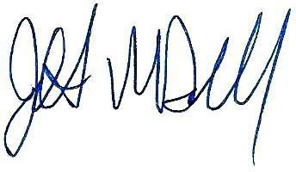

Jonathan MacDougall, PE Staff Structural Engineer

Enclosures: Appendix A – Photo Pages Copy: File

P:\Jobs\2022\2022-066 Bethlehem - Visitor's Center, 2182 Main Street, Bethlehem, NH\Reports\Roof Assessment Letter Report - Revised\Bethlehem Visitor Center Roof Assessment Letter Report 11-09-22.doc

**APPENDIX A**

**Photo Pages**

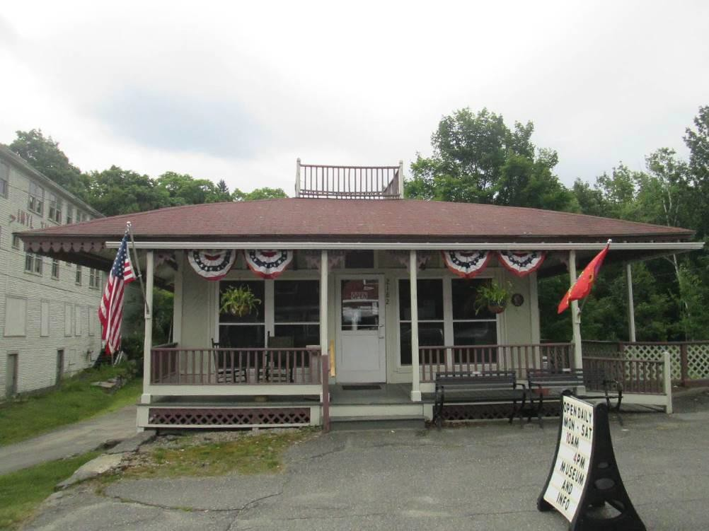

Photo 1: Visitors Center from Main Street.

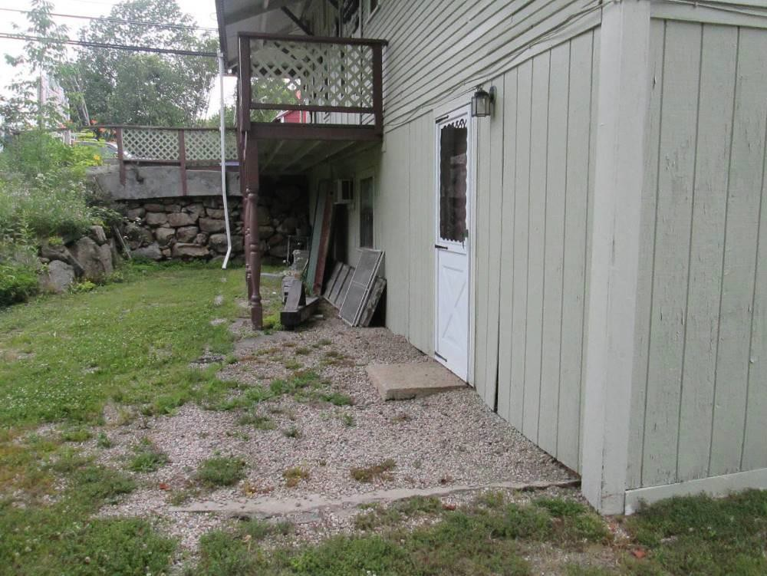

Photo 2: West side of building.

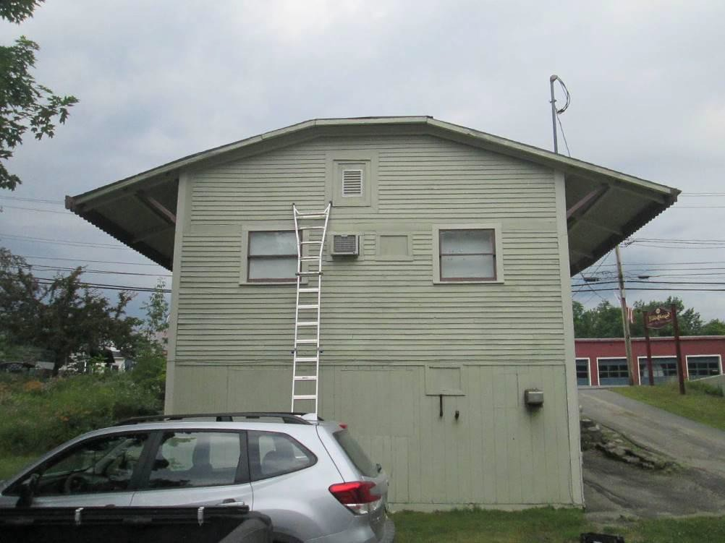

Photo 3: Back of building.

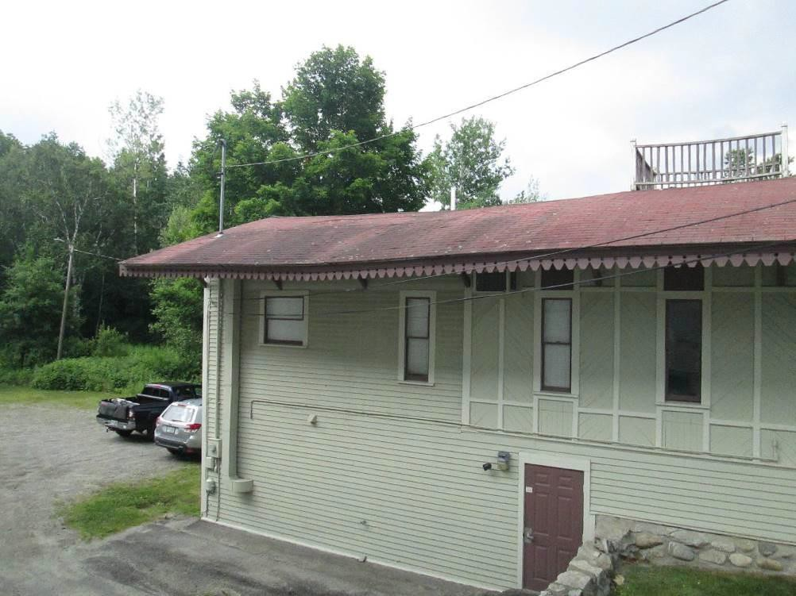

Photo 4: East side of the roof.

Note: Siding extends to the ground.

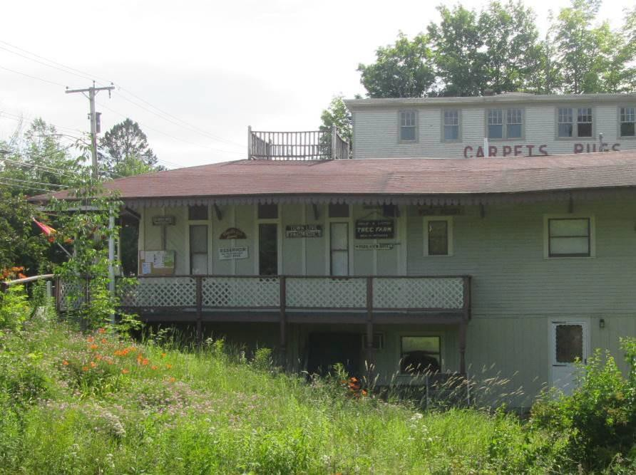

Photo 5: Building from west side.

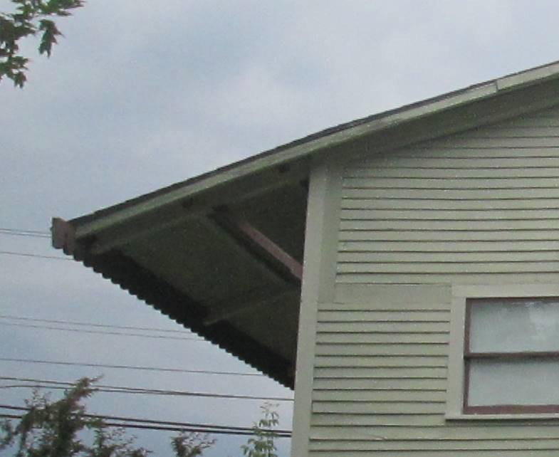

Photo 6: West eave from the back of the building.

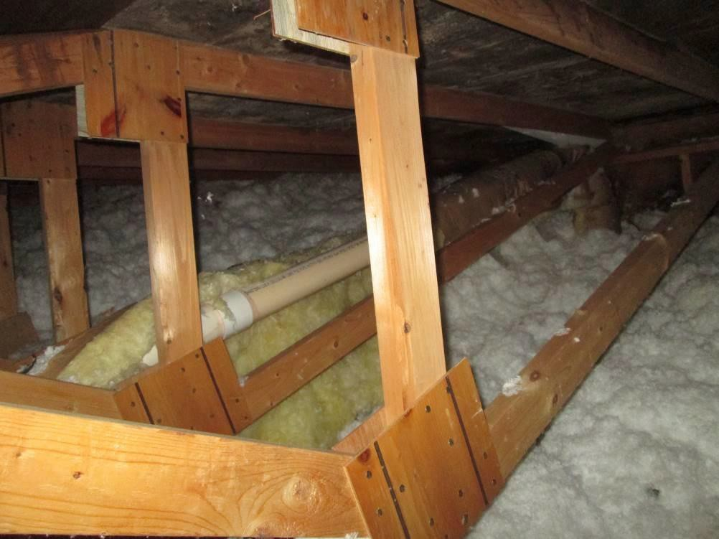

Photo 7: Roof trusses at the south end of the roof.

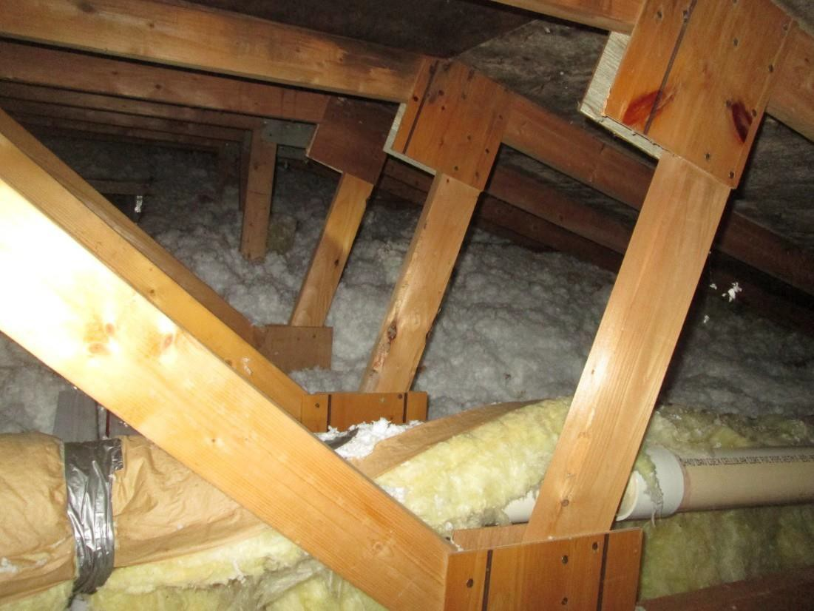

Photo 8: Roof trusses at the south end of the roof.

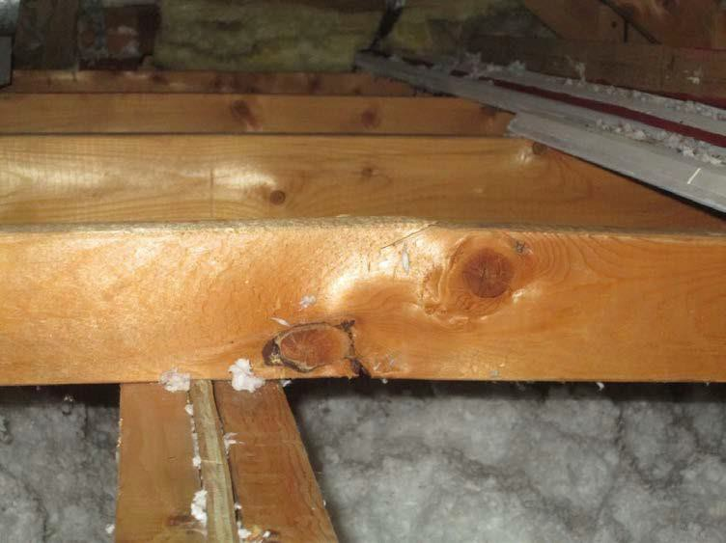

Photo 9: Roof truss bottom chord over central beam.

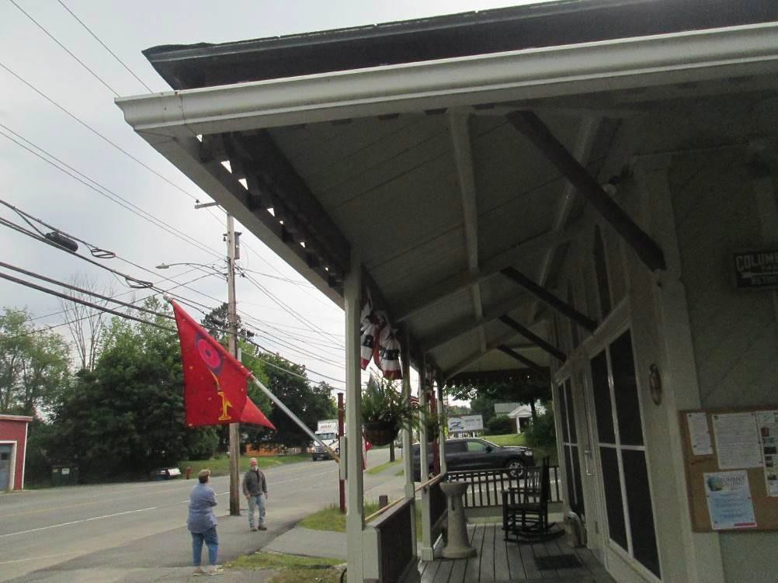

Photo 10: Eave framing.

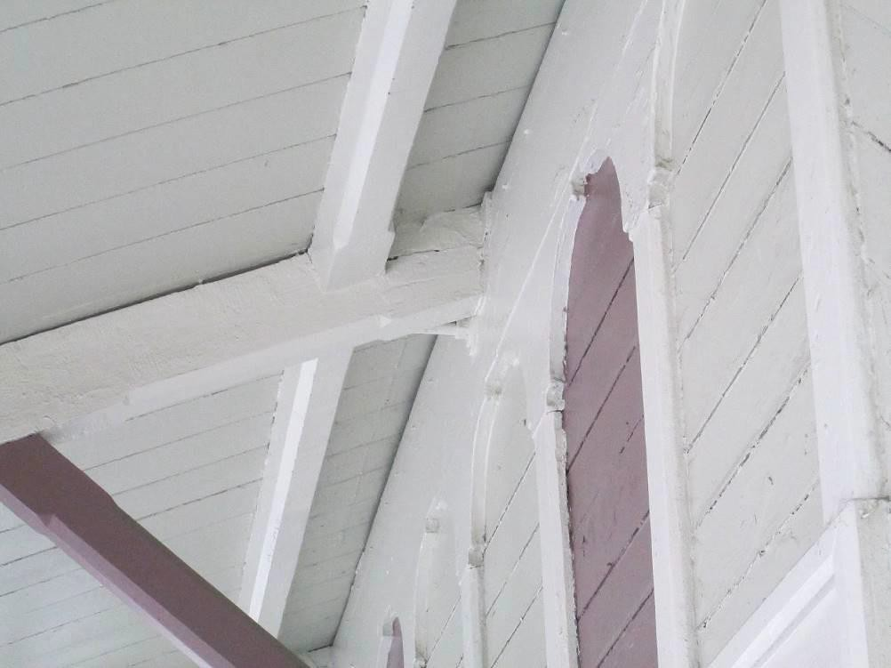

Photo 11: Cracking in the eave rafter at face of building.

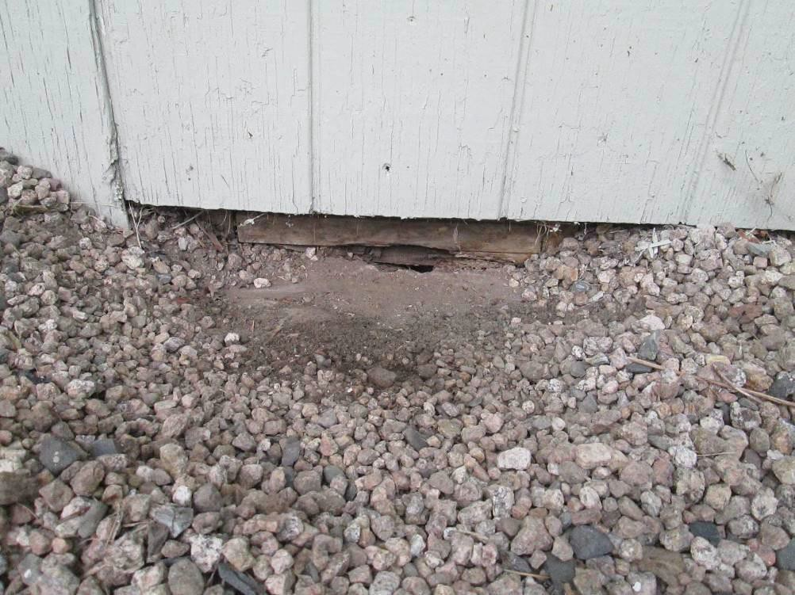

Photo 12: Grade at foundation slab and basement framing.

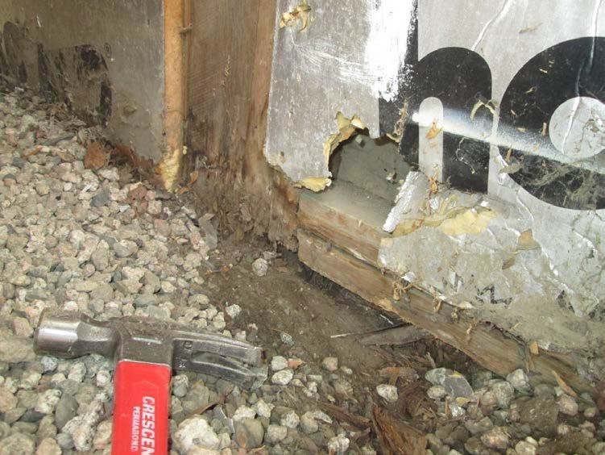

Photo 13: Exposed framing of the west wall at ground level.

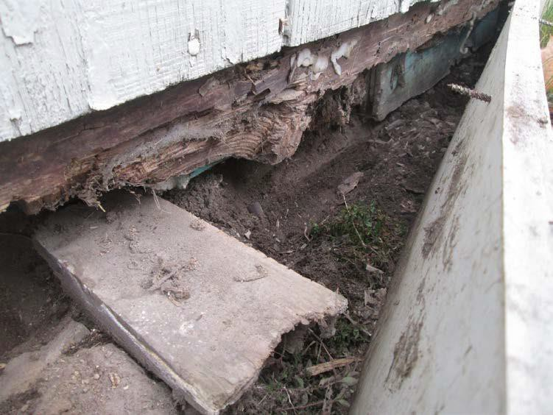

Photo 14: Exposed framing of the south wall at ground level.

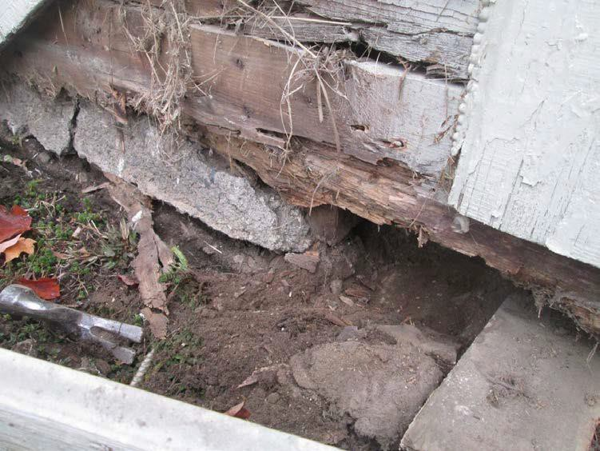

Photo 15: Exposed framing of the south wall at ground level

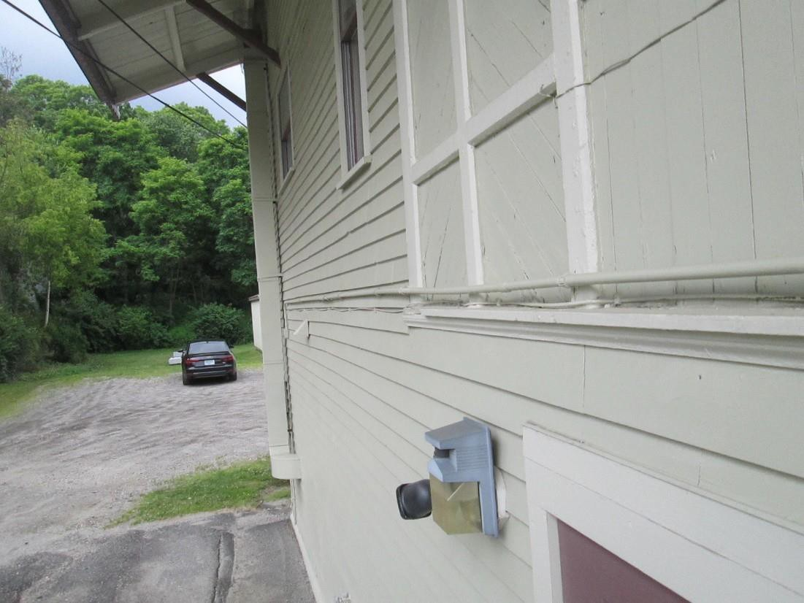

Photo 16: Siding on east side of building.

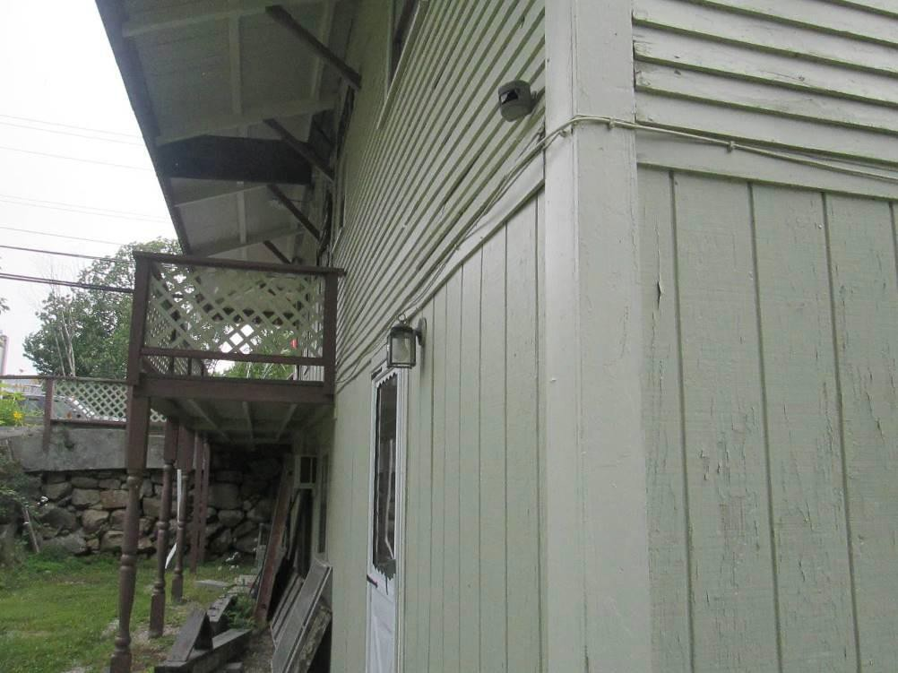

Photo 17: West wall bulge at main floor level.

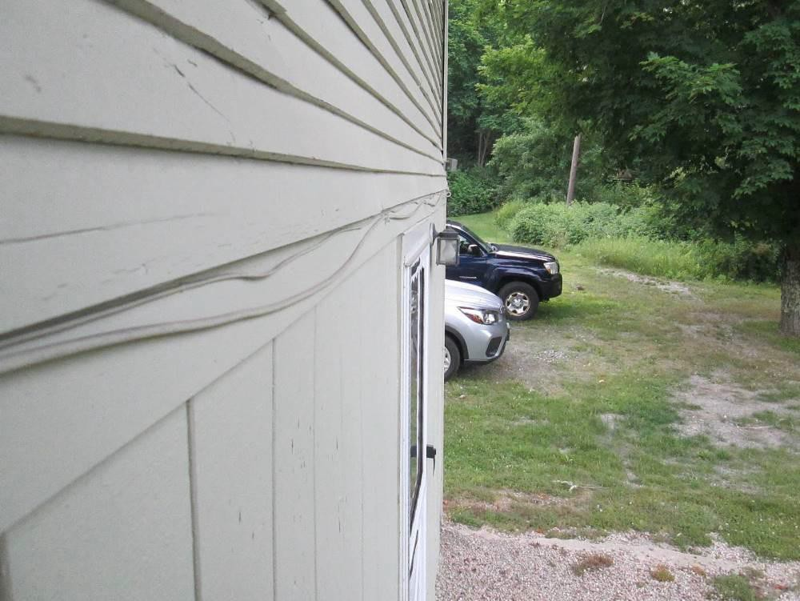

Photo 18: West wall bulge at main floor level.