Bethlehem Board of Selectmen

Meeting Minutes

September 11th, 2023

In person –Chairman Morris, Selectman Hibberd, Selectman Strand, Selectman Caplain, and Selectman Bruno.

Chairman Morris opened the meeting with a moment of silence in remembrance of the 2001 Terror Attacks.

Public Input- Barry Zitzer recognized the victims of September 11, 2001 and the military coup d'état in Chile which took place 50 years ago today.

**Minutes 8/28 Selectman Hibberd made a motion to approve the minutes from 8/28. Selectman Bruno seconded and all were in favor.**

Bravo Award- Selectman Bruno recommended Deputy Chief Brian Charland for the Bravo award because of his outstanding service during the transition from full time to part time of Chief Anderson’s position.

**Chairman Morris made a motion to approve Deputy Chief Charland for the Bravo award. Selectman Hibberd seconded and all were in favor.**

Rec accounts- receivable Chairman Morris opened discussion on rec bad debt explaining that the rec director tried to receive payment on several occasions and the accounts were from before she started with the town.

**Selectman Strand made a motion to write off the debt in the amount of $2994.25 from the rec accounts receivable. Selectman Caplain seconded and all were in favor.**

A week without driving proclamation- Selectman Caplain explained that he is on the Complete Streets Advisory Committee, and they have adopted the week without driving proclamation. The intent of the proclamation is to bring awareness to those with mobility issues. Selectman Bruno stated he read the proclamation which included statements pertaining to greenhouse gases which were not included in the original proclamation that focused primarily on mobility issues. Chairman Morris also noted the revised proclamation remarking mobility issues in our region are even more difficult given the lack of public transportation. Selectman Strand did not have any objections or concerns to the proclamation, however suggested the board motions to support a week without driving rather than the proclamation.

**Selectman Strand motioned to support a week without driving October 2nd thru October 8th. Selectman Hibberd seconded and vote carried 4-0. Selectman Caplain abstained.**

Signature authority for Mary Moritz- **Chairman Morris made a motion to delegate signature authority to Mary Moritz. Selectman Caplain seconded and all were in favor.**

Ammonoosuc River LAC Member- Chairman Morris updated the board that the Ammonoosuc River Local Advisory Committee is looking for new members to represent Bethlehem.

Eddie Qi- Chairman Morris introduced Eddie Qi. Mr. Qi addressed the board stating he felt the mural located near the gazebo on Main St had “666” on it to which he believes is the mark of the devil. Mr. Qi continued that the mural also had symbols used by pedophiles and he felt his constitutional rights were being violated. Chairman Morris noted the select board does not have an official comment noting that legal had been advised of Mr. Qi’s correspondences. The artist of the mural, Asia Scudder, was saddened when she was notified that her work had offended someone and stated that she did not have symbols of the devil or pedophiles in her art. Ian Dowling asked for clarification as to what the complaint had been. Eddie Qi explained that he felt his constitutional rights had been violated because of the mural. Mr. Dowling thanked the artist for her work. Allegra Wright stated she believes the mural is beautiful and asked the artist not to change anything based on one objection. Jared Sullivan stated he was glad Eddie Qi brought forth his concerns to the select board because that is the forum to have the discussion. Mr. Sullivan continued that he supported the artist’s work. Stephen Dignazio, Andrea Bryant, Casey McDonald, Julie Seeley, Chris McGrath, and Dick Robbie spoke on behalf of the mural. Rich Southwell noted he has attended select board meetings and signs on public property, proclamations, and art on town property have been discussed. Mr. Southwell continued he would like to see more discussions on town business discussed using the parking lot project that was over budget and the need for a new transfer station as examples. Clay Morris asked if any laws had been broken by having the mural on public property and if any taxpayer dollars had been allocated. Selectman Caplain replied that tax dollars had been allocated for legal counsel regarding Eddie Qi’s correspondence.

**Selectman Caplain made a motion to ask the artist to put the mural back where it was previously located. Selectman Hibberd seconded and all were in favor.**

Traffic Calming update Selectman Caplain thanked North Country Counsel for the work they conducted to get the traffic calming study complete. He updated the board that NCC would share the report once it’s done in the next couple of weeks. Chairman Morris stated she observed that traffic did slow on Main St during the study. Chuck Philips encouraged the board to consider extending the traffic calming measures further down Main St. Chris McGrath objected to the cross-walk cones and if something should be permanent he would urge the board to have a warrant so the town could vote.

RFP Visitors center- Chairman Morris introduced the RFP for the construction work at the visitor’s center. The board agreed the deadline should be October 31st 2023.

**Selectman Caplain made a motion to approve the RFP with a 10/31/2023 deadline. Selectman Hibberd seconded and all were in favor.**

Online Auction Demonstration- Selectman Strand did a demonstration of the online auction tool Better World.org.

Liaison/Committee Update Chairman Morris updated the board on the façade grant that the committee is recommending.

**Selectman Caplain made a motion to approve the façade grant. Selectman Strand seconded and all were in favor.**

Selectman Strand updated the board that the Transfer Station Committee continues to look for grant funding. Chairman Morris noted the town should be collaborating with grant submissions to limit competing against ourselves.

Non-public Session per RSA 91A-3 II (personnel, reputation, and legal) Chairman Morris made a motion to go into non-public for reasons of Legal, personnel, and reputation. Selectman Hibberd seconded and roll call followed.

The board discussed personnel.

**Chairman Morris made a motion to adjourn at 8:30. Selectman Hibberd seconded, and all were in favor.**

Respectfully submitted,

Mary Moritz

Town Administrator

Attachment A

Eddie Qi Notice to Remove

**Notice of Demand to Remove Mural "Renewal Dance" from Public Area in Bethlehem, New Hampshire**

# Notice to agent is Notice to Principal and Notice to Principal is Notice to Agent

I, ***£J.J,****e* ,Q ; First and Last Name, one of the people (as seen in New Hampshire Constitution Bill of Rights Article 1), Sui Juris, am serving you with this notice so

that you and your agents may provide due care as the Trustees and Servants of the People and remember your oath which binds you.

**Please take notice:** In a republic, all political power is vested in and derived from the People. In fact, this right is inherent in the People by decree of God and therefore, no government can have any power unless it is granted such powers by the People. As the Grantors, it is the People's right to have full authority over their Trustees, all state and town officials, who are the people's voluntary, Public Servants. Trustees are to defend the Liberty Interests of the People. (See evidence below)

# New Hampshire Constitution Bill of Rights Article 1. [Equality of Men; Origin and Object of Government]

All men are born equally free and independent; Therefore, all government of right originates from the people, is founded in consent, and instituted for the general good.

June 2, 1784

# Maxim of Law: All political power is inherent in the people by decree of God, thus none can exist except it be derived from them, American Maxim.

**Please take notice:** It is my duty as one of the People to provide you with a frequent reminder of the fundamental principles of law. (See evidence below)

**New Hampshire Constitution Bill of Rights [Art.] 38. [Social Virtues Inculcated.]** A frequent recurrence to the fundamental principles of the constitution, and a constant adherence to justice, moderation, temperance, industry, frugality, and all the social virtues, are indispensably necessary to preserve thP- blessings of liberty and good government; the people ought, therefore, to have a particular regard to all those principles in the choice of their officers and representatives, and they have a right to require of their lawgivers and magistrates, an exact and constant observance of them, in the formation and execution of the laws necessary for the good administration of government.

June 2, 1784

# Maxim of Law: The government is to be subject to the law, for the law makes the government. C.L.M.

**Maxim of Law: Obedience makes government, not the name by which it is called. C.L.M. Please take notice:** It is no one's right to display "art", or any other item, in or on a public space.

**Please take notice:** The main objective of the government is to protect and preserve the personal,

natural and unalienable rights, private property, and liberty interests of the People, and to uphold the law of God. It is the inherent right of the People to require an exact and constant observance of

the law. The New Hampshire Constitution is the Law. Regarding religious freedom, the New Hampshire Constitution states:

# New Hampshire Constitution Bill of Rights

**[Art.] 5. [Religious Freedom Recognized.]** Every individual has a natural and unalienable right *to* worship God according to the dictates of his own conscience, and reason; and no subject shall be hurt, molested, or restrained, in his person, liberty, or estate, for worshiping God in the manner and season most agreeable to the dictates of his own conscience; or for his religious profession,

sentiments, or persuasion; provided he doth not disturb the public peace or disturb others in their religious worship.

# Maxim of Law: The main object of government is the protection and preservation

**of personal rights, private property, and public liberties, and upholding the law of God. American Maxim.**

**Please take notice:** lt'is the sworn duty of public officials to protect the rights of the people, including their religious freedoms. It is not your duty to allow so-called "art" to be displayed on public property, whether some people like it or not. The mural "Renewal Dance" is highly offensive and does not belong on public property for the following reasons:

**Please take notice:** I am a Christian. As a Christian, I am strongly against the number "666". The number "666" represents "Mark of the Beast" - whoever has this symbol will be eternally condemned.

**Holy Bible: Book of Revelation, 13:18, KJV.** "Here is wisdom. Let him that hath wit, count the number of the beast: for it is the number of a man, and his number is six hundred threescore and six."

There are "666" symbols inside the mural displayed in Bethlehem called, "Renewal Dance". The "666" symbol signs are strongly against my religious belief and do not belong on any public property. "Renewal Dance" is located on property owned by the people in a public area. As one of the People, I strongly disagree with what the mural represents. This mural disturbs the public peace and my religious faith.

**Please take further notice:** attached you will find an unclassified FBI file titled, "Symbols and Logos Used by Pedophiles to Identify Sexual Preferences." You also will find the definition of Pedophiles.

*"Pedophiles, to include those who sexually abuse children as well as those who produce, distribute, and trade child pornography. are using various types of identification logos or symbols to recognize one another and distinguish their sexual preferences."*

The unclassified symbol "Little Boy Lover" is *very* similar to the symbol inside the mural "Renewal Dance". This symbol disturbs me every time I walk or drive around the town. I do not feel safe when I and my family walk or drive past this mural. My Right of Conscience is protected by the NH Constitution. (Please see evidence below)

# New Hampshire Constitution Bill of Rights

**[Art.] 4. [Rights of Conscience Unalienable.]** Among the natural rights, some are, in their very nature unalienable, because no equivalent can be given or received for them. Of this kind are the Rights of Conscience.

June 2, 1784

**Please take final notice that it is my wish, order, and demand** for the Bethlehem Board of Selectmen (Veronica Morris, Mike Bruno, Nancy Strand, April Hibberd and Bruce Caplain) to take this mural, "Renewal Dance", out of the town owned public area. Or, to show me where in the Constitution anyone possesses the right to use public property or funds, to display or erect anything that is contrary to the religious rights of the People.

Any man or wc,man denying these claims are true must rebut them, point by point, under penalty of pe1jury, in the form of a sworn affidavit within five (5) business days. Any man or woman who decides to suppress this notice agrees to pay$ l 0,000.00 (ten thousand dollars) and any disputes by any public officials or private actors who are bound by contract to the New Hampshire State Constitution agrees to have these matters heard before an Arbitrator of my choice, and agrees that no other court can hear this matter. Failure to respond means that by tacit acquiescence you agree that all claims are true.

You can provide remedy by adhering to the law of the land, and to the lawful instruction given to you by the People, whose rights you swore to protect. You do not have to agree with th instruction, yet, in every instance, you must comply. If you can not perform your duties as instructed, if you can not follow the constitution, your immediate resignation from your official position is acceptable.

Please mail your affidavit to:

Eddie Qi

59 Pleasant Street

Bethlehem, NH 03574

This notice is sent to you in peace and with the love of Christ, so that you may provide due care to those who have all political power: We the People.

Autograph

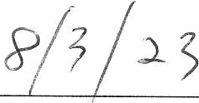

Date

Mural "Renewal Dance"

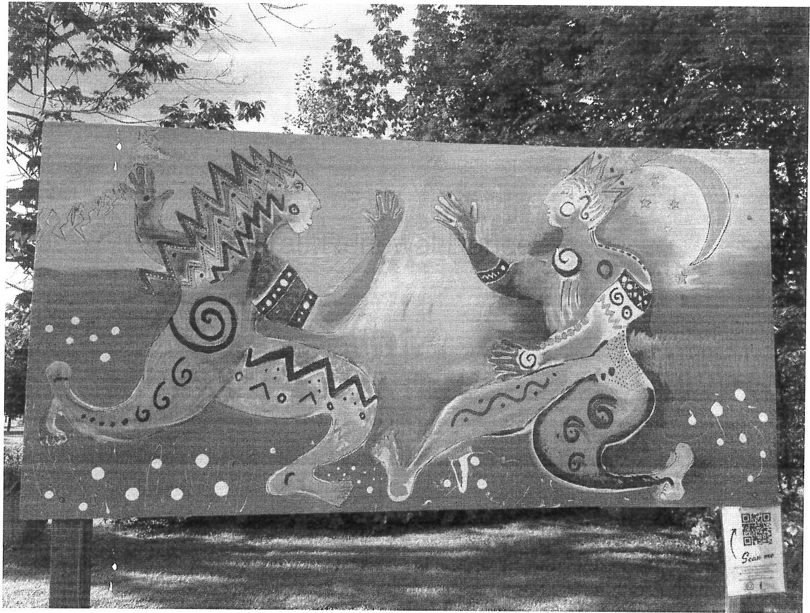

**UNCLASSJFIED//LAW ENFORCEMENT SENSITIVE**

**FEDERAL BUREAU OF INVESTIGATION**

**INTELLIGENCE BULLET.IN**

Cybcr Division, Innocent Images National Initiative

31 January 2007

(U) **Symbols and Logos Used by Pedophiles to Identify Sexual Preferences**

(U//FOUO) This intelligence bulletiu addresses Crimes Against Children Standing lntelligenee Requirements Set coutained in Q-FBJ-2200-005-06. HRWC CAC-VLA.5.

(U//LES) Pedophiles, to include those who sexually abuse children as well as those who produce, distribute, and trade child pornography, are using various types of identification logos or symbols to recogui2e one another and distinguish their sexual preferences. To specifically indicate the pedophile:s gender preference, members of pedophilic organizations encourage the use of descriptions such as ''boylove", ·'girllove", and "childlove."1 These symbols have been etched into rings and formed into pendants, and have also been found imprinted on coins·.

(U) TI1e BoyLover logo (BLogo) is a small blue spiral-shaped !naugle sunounded by a larger triangle, whereby the small triangle represents a small boy and the larger triangle represents an adult man.2 A variation of the BLogo is the Little Boy Lover logo (LBLogo), which also embodies a small spiral-shaped triangle within a larger triangle; however. the comers of the LBLogo are rounded to resemble a scribbling by a young child.3 Images of the BLogo and LBLogo symbols are depicted below.

UNCLASSIFIED

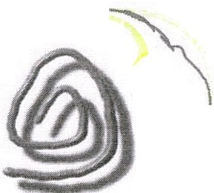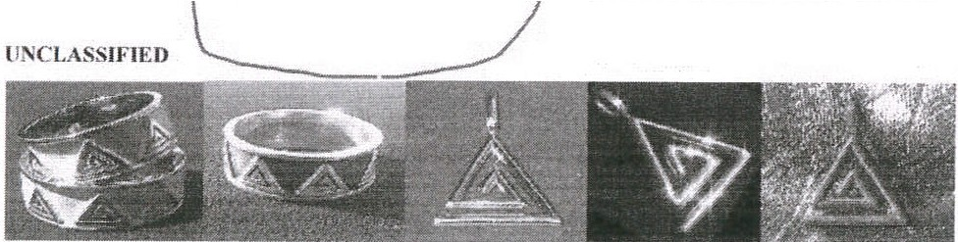

**(U) BLogo aka "Boy Lover"**

UNCLASSLFIED

**(U) LBLogo aka "Little Boy Lover"**

UNCLASSIFJED

(U) BLogo imprinted ou coins

(U) BLogo jewelry

UNCLASSIFIED//LAW ENFORCEMENT SENSITIVE

**UNCLASSIFIED//LAW ENFORCEMENT SENSITIVE**

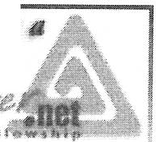

(U) The GirlLover logo (GLogo) depicted below is a small heart surrounded by a larger heart, which symbolizes a relationship between an adult male or female and minor girl.

UNCLASSIFIED UNCLASSIFIED

(lJ) **GLogo Pendant**

**(lJ) GLogo a.k.a. "Girl Lover,•· Childlove**

(U) The ChildLover logo (CLogo). as shown below, resembles a butterfly and represents non-preferential gender child abusers. TI1e Childlove Online Media Activism Logo (CLOMALl. also represented below, is a peneral purpose logo used by individuals who use (mime media such as biogs and webcasts.

lJNCLASS.lFIED

UNCLASSIFIED

**(U) CLogo a.k.a. "Child**

**Lover'" (U) CLOMAL a.k.a.**

**Childlove Online Media**

**Activism**

(U//LES) FBI investigations in several cities have uncovered several symbols used by pedophiles to proclaim their attrnction lo children. After a seizure of a subject's computer in connection with an Innocent Images case in the Jacksonville Division, a Computer Analysis Response Team forensic examiner came across an unfamiliar symbol that was integrated into a Web site banner named "ATBOYS.COM. where the "A" in '"ATBOYS" was actually the BoyLove symbol and written as follows: .£,TBOYS.com. It was further detem1ined tha!

''ATBOYS" is an acronym for Attracted To Boys.5 These pedophilia symbols also appear on Web sites such as one oftJ1e banners advertised on [www.boylover.net,](http://www.boylover.net/) shown below.6

UNCLASSIFIED

***Pniut.lN***

**.,.hr.**

f ***:t***

(U)**Boylover.net banner**

**lJNCLASSlFIED//LAW ENFORCEMENT SENSITJVE**

(U//LES) In another incident, FBJ Sacramento was alerted by the California Department of Justice about an unusual marking on a coin. Research of the marking concluded that the BoyLovcr logo (Blogo) was imprinted on the from of the coin, and the phrase "Kids Love Pedos'' was engraved on the back of the coin.7 *(Coins depicting the BLogo are pictured on page one.)* The appearance of the Blogo on coins is another method used by pedophiles to announce their sexual preferences.

(U) Pedophilia symbols (m jewelry, coins, Web sites and other effrets arc indicative of advertisement methods used by child sexual predators to promote their cause. Pedophile activists advocate for the social acceptance of sexual relationships between adults and children. 11,ese organizations seek to detl'imjnalizc sexual relationships between adults and children and to legalize child pornography based on their belief that children have the ability to consent io sexual acts.

(U//LES) Identical or similar jewelry and symbols as described in this intelligence bulletin should raise suspicion of possible pedophilia activity when found during searches.

Investigators should also be attentive to pedophilia symbols advertised on Web sites. During

examinations of computer files, inves1igators should be conscious of subjccis who try to conceal child pornography by labeling them with symbols instead of the typical suggestive explicit names.

**(lJ) This Jntclligence Bulletin was prc1>arcd by the FBl's Cybcr Division. Innocent Images lfnit. Please address all comments or tJuestions to the Innocent Images Unit at 301-586-)613.**

**lJNCLASSIFIED//LAW ENFORCEMENT SENSITIVE**

3