Minutes of Bethlehem Energy Commission
February 4, 2025

Present: Dan Crosby, Mary Lou Krambeer, David Van Houten, Josh Lieberman, Scott Caisse, Marni Hoyle
Excused: Bruce Caplain (Select Board Liaison), Chuck Phillips,

Mission The Bethlehem Energy Commission encourages and supports economically and environmentally sensible energy practices in Bethlehem, NH.

We welcomed our newest Bethlehem Energy Commission member -- Marni Hoyle.

-January minutes moved by David Van Houten and seconded by Marni Hoyle. Approved.

-Guest speaker: Bob Francis, Bethlehem Building Inspector and Enforcement Officer.
Bob sees about 20-30 new houses a year. About 10-15 additions a year. He said while there are not a lot highly energy efficient homes going up, in the last few years he has seen some highly efficient wood-framed homes (using 2 x 8s) and double walls (filled with cellulose). Bethlehem doesn’t currently do insulation inspections. When Bethlehem gives out Building Permits applicants also receive the State of NH EC1 (energy code #1) form. This follows the State of NH 2023 building code which requires a blower door test before occupancy. Bob suggested we encourage education around the two biggest leakage areas in homes -- attics and the basements. Perhaps Bob could attract more people to a future “Button-up” workshops.

-Village District Waste Water solar project solar up and running.

-Village District Drinking Water Plan -- Dan and David went to meeting in January. Commissioners are considering putting in heat pumps in the two buildings (switch from propane to electric). They may have to hire an engineer to plan for heat pumps. Then look for money to put in a 100 kwh system.
To Do: Dan, Josh and David will go to Village District – to discuss heat pumps.

-Main Street Solar Initiative: winter here project has slowed down.

-Rambling Woods solar project: Next step -- Dan and Melissa will go to a Rambling Woods board meeting to further discuss the project.

-Battery project Eversource has approved underwriting 50% of the cost of battery storage for municipal building up to $200,000 (this number originally was set at $10,000). Participants will also be able to apply for an additional 30% tax credit from the federal government. Next step --- Melissa Elander of Clean Energy NH will give update.

-Community Power Coalition of NH (CPNNH) new 6-month rate, starting February 1, set at 8.9 cents per kWh. Will rise to 9.7 cents February – July. Eversource rate Feb – July is 8.9 cents. Since CPCNH’s launch in April 2023 – July 2025 CPCNH’s Granite Basic pricing will have averaged 8.7% savings relative to Eversource’s supply cost.

-Other
-BEC annual report in-progress and due on February 7.

-BEC is supporting the Conservation Commission’s lighting warrant articles and sending letters of support to local newspapers.

Future Project List
-create a on-going reporting chart on our various projects to be used in annual reports (noting usage changes and rates change)
-look into selling municipal solar RECs
-connect with local residents about selling their RECs to Community Power Coalition of NH

Meeting adjourned at 7:20.

BEC Meetings in 2025 (first Tuesday of the month):
March 4 Scott Caise will run the meeting.
April 1 (really!), May 6, June 3, July 1, Aug 5, Sept 2, Oct 7, Nov 4, Dec 2

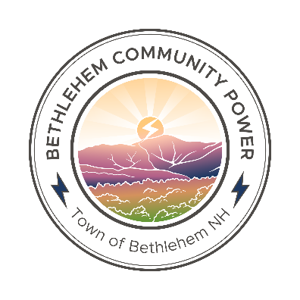

Community Power Coalition of NH
2024 Annual Report to Bethlehem

In March 2024, Bethlehem Community Power was adopted by Town Meeting vote.

Our non-profit Community Power program launched service in June 2024 and has been saving Bethlehem electric customers money while also offering expanded energy choices.

To date, Bethlehem Community Power has provided 2,000 megawatt-hours of electricity, and resulted in $14,000 of savings for electric customers in Bethlehem (as of September 30th, 2024).

This program provides electricity to approximately 1,435 electric accounts in our Town. Of these accounts, 13 have chosen products with higher levels of renewable energy.

Bethlehem is part of the Community Power Coalition of New Hampshire (CPCNH), a statewide non-profit power agency serving over 50 Community Power programs statewide (as of October 2024). The Coalition has created $20,000,000 in savings for customers in Community Power programs statewide. This local control model empowers us to collaborate regionally and statewide to develop beneficial local energy programs and projects.

There are approximately 56 residents and businesses in Bethlehem who generate their own renewable electricity and utilize net metering. While problems with utility regulations are currently preventing these customers from choosing to supply power to Bethlehem Community Power, the Community Power Coalition of New Hampshire is working to resolve those issues to enable more local power options.

Mary Lou Krambeer and Dan Crosby are the Member Representative and Alternate from Bethlehem to CPCNH. CPCNH is governed by its municipal members who elect its Board of Directors.

Residents and businesses can visit https://CommunityPowerNH.gov/bethlehem to learn more, see our rates, opt into or out of Bethlehem Community Power, and choose a cleaner energy option.

