TOWN OF BETHLEHEM, NEW HAMPSHIRE

NATURAL RESOURCE INVENTORY – EXECUTIVE SUMMARY
May 2025

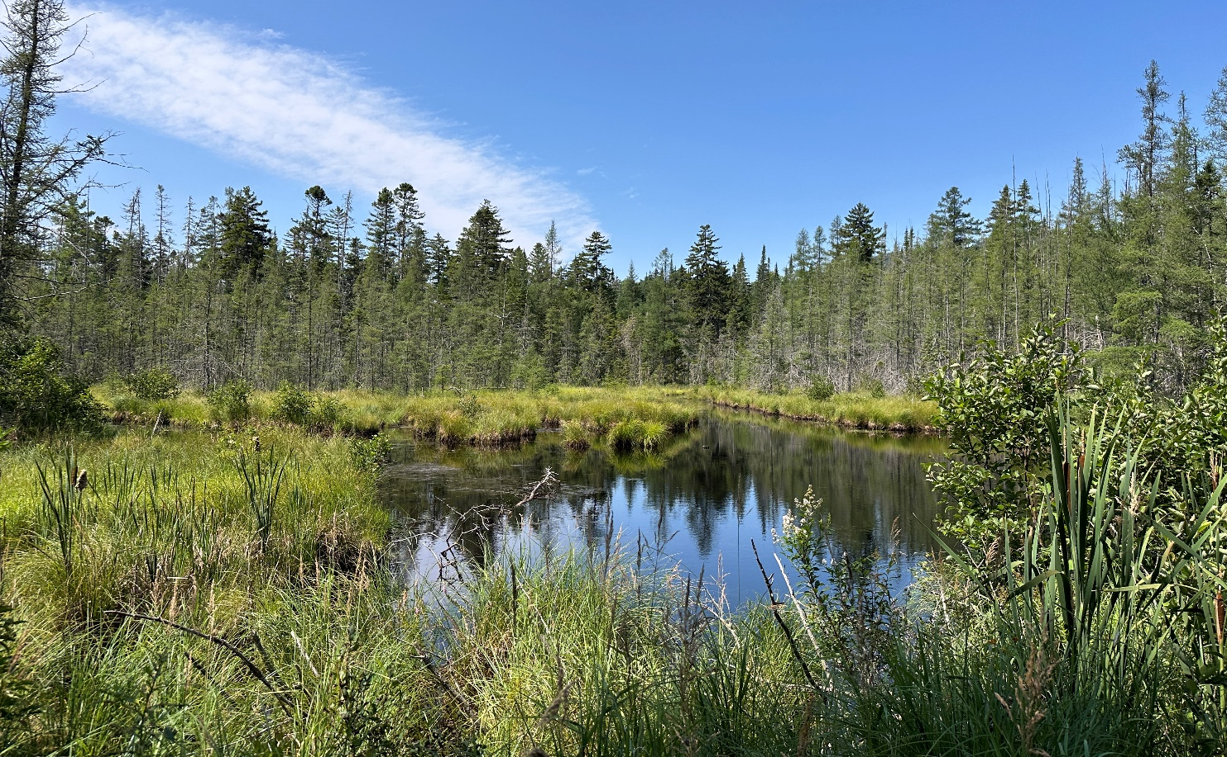

Report Prepared by:
Watershed to Wildlife / Elise Lawson
Natural Resource Consultant
507 West Darling Hill Road
West Burke, VT 05871

Report Additions and Review by:
Bethlehem Conservation Commission
Town of Bethlehem, NH
2155 Main Street
Bethlehem, NH 03574

Commissioned and funded by the Bethlehem Conservation Commission

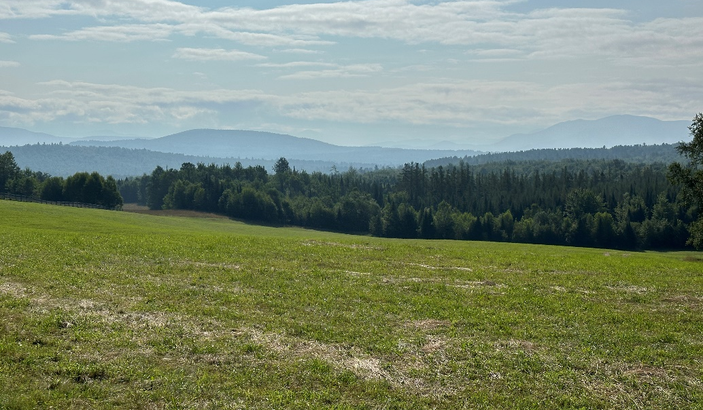

DEDICATION

This Natural Resource Inventory is dedicated to the residents of Bethlehem, New Hampshire.

BETHLEHEM Conservation Commission
Cheryl Jensen, Chair
Margaret Gale, Treasurer
Ivan Ash
Chris Jensen
Joanne Jones
Wendy Jordan
Colin Lunette
Rachelle Lyons
Veronica Morris

Cover Photo: Wetland along Blaney Road, Bethlehem, NH
Photo on current page: Scenic View off Prospect Street looking towards the Presidential Range of the White Mountains.

Introduction and Goals

The Town of Bethlehem, New Hampshire is rural and mostly forested containing 90.95 square miles (58,205.89 acres) of land including 228.75 acres of ponds and open water, and 230.23 miles of rivers and perennial streams. The White Mountain National Forest is prominent, with 47.4 square miles, located in the eastern half of town. Bethlehem’s geography is quite diverse, ranging from flat floodplain areas along the Ammonoosuc, Gale and Zealand Rivers to rugged hilly areas with steep slopes throughout the White Mountain National Forest. There are several mountains over 4,000 feet including Mount Field (4,323 feet), North Twin (4,293 feet), Mount Willey (4,285 feet), Mount Tom (4,053 feet), and Mount Hale (4,050 feet). Nearly 90% of Bethlehem is forested.
In New Hampshire conservation commissions are tasked with many responsibilities, including environmental education, land protection, wetland evaluation and more. Although some of these are optional, creating inventories of natural resources is a statutory requirement (RSA 36-A:2). A Natural Resource Inventory (NRI) provides a clear picture of where a town’s natural resources are located, which of them are significant, and why.

Examples of how an NRI can be used include:
- Guiding the conservation commission’s goals and projects
- Advising the Planning Board and other government entities involved in making land use decisions
- Informing the town’s Master Plan process and recommendation of Zoning Ordinances
- Assisting in the evaluation of wetland permit applications
- Creating a foundation for a Conservation Plan
- Providing background for public forums on natural resources and environmental topics
- Integrating information into environmental education curricula in schools

Goals of the Natural Resource Inventory
In 2023 the BCC hired natural resources consultant and biologist Elise Lawson, owner of Watershed to Wildlife, to prepare this NRI. The following goals guided its development, and resulted in the maps, data and narrative.

- Promote conservation of water, forested land, wildlife habitat, wetlands and unique co-existing natural resource features throughout the town.
- Create a document that can be incorporated into future updates of Bethlehem’s Master Plan
- Identify areas for future conservation efforts, and areas of contiguous open space and wildlife corridors
- Maintain inventories of natural and scenic resources, including aquifers, open water, steep slopes and hilltops
- Provide the Town of Bethlehem with new accurate, standardized coverages that can be integrated into the existing GIS database
- Increase awareness of the values of the characteristics of Bethlehem including forest and water resources, scenic view areas, recreation areas, riparian buffer habitat, and wetlands with associated wildlife habitat through public presentations and discussions.

Habitat Area Summary Table
The table below is a summary of different habitat areas in acres, square miles, and percentage of town land area.
Habitat Type | Acres | Square Miles | Percentage of Town Land Area
Town of Bethlehem | 58,205.89 | 90.95 | 100%
Conservation Land Total  Land Excluding WMNF | 35,138.57  4,765.99 | 54.90  7.45 | 60.4%  8.2%
Ponds and Open Water | 228.75 | 0.36 | 0.4%
Wetland Complexes (from National Wetland Inventory data & field work) | 2,183.28 | 3.41 | 3.8%
Hydric Soils – poorly and very poorly drained* | 3,602.12 | 5.63 | 12.9%
Floodplain Zones (FEMA) | 1,169.26 | 1.83 | 2.0%
Aquifers | 3,370.54 | 5.27 | 5.8%
Northern Hardwood Conifer | 26,933.16 | 42.08 | 46.3%
High Elevation Spruce-Fir | 12,038.11 | 18.81 | 20.7%
Hemlock-Hardwood Pine | 7,537.20 | 11.78 | 12.95%
Dense Softwood Cover | 6,903.17 | 10.79 | 11.9%
Permanent Wildlife Openings | 1,347.79 | 2.11 | 2.32%
Cliff, Talus and Alpine | 259.11 | 0.40 | 0.5%
Farmland Soils – prime, statewide and local importance* | 12,110.02 | 18.9 | 43.5%
Steep slopes – 20% and greater* | 9,139.54 | 14.28 | 32.8%
Steep slopes – 30% and greater* | 2,756.52 | 4.30 | 9.9%
* = Data extrapolated from NRCS soil data. This data does not include the WMNF so percentages based on area outside of WMNF

DISCUSSION – RECOMMENDATIONS FOR FUTURE ACTIONS AND OPPORTUNITIES

This project is an inventory of natural resources, including a written report, maps, and a digital database in GIS format. It is the property of the Town of Bethlehem and was funded by the Bethlehem Conservation Commission. The data from this project is compatible for integration with the existing Town GIS. Efforts from this project will aid in future work and inventories, as well as provide tools to guide future development and conservation decisions in Bethlehem.
Based on results from this study, Elise Lawson and the Bethlehem Conservation Commission offer the following additional recommendations:
- Surface Water Protection - Bethlehem’s residents obtain drinking water from town- treated water as well as from personal drilled or dug wells. The Village District of Bethlehem uses water drawn from the Gale and Zealand Rivers in town. Maintaining good water quality is one of the highest priorities for the Bethlehem Conservation Commission.
Currently, water quality in Bethlehem’s streams and rivers is in very good to excellent condition. Water quality should continue to be addressed not only in large rivers like the Ammonoosuc, Gale, and Zealand Rivers, but also in the headwater streams and brooks that feed into these larger river systems.

  - Where possible, work to maintain or enhance riparian habitat adjacent to headwater streams and brooks. Any wetland setback should also apply to all riparian habitat along perennial streams.
  - Continue monitoring water quality in the Ammonoosuc River as well as some of the smaller feeder streams in town.
  - The town should update any potential contamination source location inventory at least on an annual basis and ensure that compliance measures (secondary containment structures, and spill kits) are in place.
- Aquifer Protection - Based on the locations of the underlying aquifers in Bethlehem, it is important to protect the quality of groundwater, brooks, streams, and aquifers in town. Future water supplies are an invaluable natural resource for Bethlehem and the abutting towns. Those areas with the highest water quality and quantity, whether zoned residential or industrial, should have the least impactful development. Correspondingly, where the least potential for aquifer recharge exists, the more desirable and suitable the area is for development, barring other development concerns.
- Implement Best Management Practices (BMPs) within aquifer areas.
- Monitor septic system plumes with a focus on parcels adjacent to rivers, wetlands, and aquifers.
- Monitor the placement of future septic systems keeping in mind the typically high permeability of many of Bethlehem’s soils.
- Develop a deeper understanding of the movement of ground water and the recharge of aquifers to better understand water resources available to Bethlehem and the larger watershed as a whole. This knowledge can also serve as an important guide to policies related to sewage treatment, solid waste disposal, landfills and risks associated with existing ground water contamination.
  - This includes knowledge, education and caution to avoid disturbing contaminated soils from 19th and 20th century landfill operations.
- Develop town-wide ordinances to help protect aquifers, including restrictions on impervious surface development and dumping of waste on top of aquifers, particularly areas with high productivity and flow.
- Climate Change – One of the most significant threats to the existing natural resources in Bethlehem is climate change. The predictions of impacts as described in the 2021 NH Climate Assessment Report should be considered by town departments and committees in planning for Bethlehem’s future.
  - Incorporate actions to minimize, mitigate and adapt to climate change impacts when making land use planning decisions. Examples include increasing culvert size for storm events, encouraging vegetation diversity on forested properties, and manage for tree species resilient to the effects of climate change in Bethlehem.
  - Develop a town energy use plan to reduce municipal and residential activities that create greenhouse gases.
  - With the passage of two Dark Sky warrant articles in March 2025, work can begin to incorporate Dark Sky initiatives - creating energy efficient lighting and reducing lighting wherever possible.
- Dense Softwood Stand Protection – Based on results from this project, there are areas that contain adequate acreage of dense softwood stands (excluding white pine stands) scattered throughout the town. These areas are beneficial to many wildlife species for cover as well as important wintering areas.
- Maintaining existing softwood stands for the benefit of the deer, moose and other wildlife populations is very important. This type of habitat could be negatively impacted by climate change.
- Where possible, investigate maintaining or possibly extending some existing softwood areas and/or connecting patches of softwood stands to increase overall size. Willing landowners can be encouraged to do so, particularly those whose property abuts wetlands and riparian habitat.
- Continued Wetland Conservation– The Bethlehem Conservation Commission recognizes the importance of wetland protection as an important means to maintaining good water quality. It is hoped that the town will continue to pursue ways to further conserve the functionality and diversity of these wetlands. An overall wetland study could help Bethlehem work with willing landowners to conserve some of these valuable wetland resources. This NRI recommends the following:
- Conduct an overall wetland study throughout Bethlehem to identify, assess and functionally rank wetlands in town.
- Revisit and update the Wetlands Conservation District Overlay to incorporate a protective buffer around wetlands in town to protect them from development pressures.
- Continue to inventory vernal pools throughout Bethlehem to enable the Conservation Commission, Planning Board, and Select Board to critique and adjust future subdivision proposals if vernal pools are likely to be impacted.
- Continue to monitor stormwater runoff and associated drainage immediately after storm events whenever possible. Treatment devices for stormwater structures should be installed and maintained, particularly within 150 feet of rivers and wetlands.
- Current development ordinances in Bethlehem, including lighting, aquifer protection, and floodplain protection, can be found at the following link. https://bethlehemnh.org/wp-content/uploads/2024/03/Zoning-Ordinance-2024.pdf
- Land Conservation – Over 50% of Bethlehem is conserved, most of it being the White Mountain National Forest. The Town has a town forest (Tellman-Johnson Town Forest), and there over 3,700 acres of land under private conservation easements. Results from this study identified additional higher priority areas for conservation. They are described below.
  - Black Brook and Associated Wetlands and Upland Area – In the north part of Bethlehem near the Townline with Whitefield is a large, unfragmented area containing a diversity of streams, wetlands, and upland habitat. The area abuts Pine Knob Conservation Land to the north, and includes large parcels of property owned by a timber company. Working to conserve this land would help protect wetlands, water quality and diverse wildlife habitat.
  - Ammonoosuc River / Alder Brook Area – This area is in the northwestern part of Bethlehem adjacent to the Brebner Farm and Forest and the newest conserved parcel by Ammonoosuc Conservation Trust. It incorporates the Ammonoosuc River, Alder Brook, Barrett Brook, and several headwater streams.
  - Indian Brook / Baker Brook Area –This area is east of The Rocks Estate and south of Route 302 in Bethlehem. It includes parts of the Indian and Baker Brooks, their associated wetlands, as well as a large area of undeveloped diverse habitat.
There are several land trust organizations which the Bethlehem Conservation Commission can work with to help purchase land for conservation or work with willing landowners to put their land in a conservation easement. These include Ammonoosuc Conservation Trust, Society for the Protection of New Hampshire Forests, and Trust for Public Land.
- Hillside and Viewshed Protection - Bethlehem’s mountainous and hilly topography, wetlands, and rivers are directly related to the town’s tourism industry, scenic beauty, and diversity of natural resources (wetlands, streams and rivers, wildlife, plants, soils, etc.). We recommend evaluating and updating the Zoning Ordinance in Bethlehem to conserve viewsheds as an important feature and tourist attraction to the area, while continuing to consider landowner rights.
- Scenic View Conservation - The potential for continued population increase throughout the town makes it wise to take a proactive approach in dealing with future development pressures and preserving the scenic vistas and beauty. Scenic easements are types of conservation easements that make protection of scenic resources possible.
- Ridgeline Development Criteria - Several municipalities throughout the state have developed ridgeline ordinances to protect ridgeline views. Bethlehem may want to review some of these and explore the possibility of implementation.
- Steep Slope Development Criteria – Develop town-wide ordinances to restrict future development and road construction at sites with over 25% slopes and limit development on slopes between 20% and 25%.
- Cooperation – Ecosystems, watersheds and wildlife habitats often transcend municipal boundaries. The health of our natural resources is often dependent on actions taken by neighboring towns. Bethlehem should continue working with government agencies, regional planning commissions, neighboring municipalities, and natural resource organizations to enhance the protection of our shared natural resources on a larger watershed-wide level.
- Work with regional planning commissions who have developed several templates for town-wide ordinances in areas from wetland and shoreline setbacks to restrictions on steep slopes, to ridgeline development.
- The Franconia Conservation Commission is interested in partnering with Bethlehem to expand their “Tri-town” effort (Franconia, Sugar Hill and Easton).
- Continue ongoing partnerships with local land trusts, high schools and colleges to encourage young people to be involved.
- Carbon Sequestration – Explore the possibility of securing funds for Bethlehem from carbon offset programs. A great resource is The Northeast Forest Carbon Program (website: https://www.northeastforestcarbon.org/). Funds from participating organizations can be used to incentivize landowners to protect their land from development for a period of time. Sustainable forestry is an important part of this process.
- Cryptocurrency Mining and its Effects on Natural Resources - Cryptocurrency mining is the process of verifying digital transactions and adding them to a blockchain ledger, typically by solving complex mathematical problems using powerful computers. While this process is needed to maintaining decentralized networks like Bitcoin, it consumes a significant amount of electricity. Much of this energy comes from fossil fuels, which contributes to greenhouse gas emissions and climate change. The environmental impact extends beyond energy use. Mining operations often require large numbers of high-performance computers that generate substantial heat, leading to increased cooling demands and water use. In some areas, mining operations have stressed local water supplies and contributed to noise pollution and land use conflicts. As cryptocurrency grows, there is increasing concern about its sustainability.
While this is not currently a widespread issue in Bethlehem, HB639 has been passed by the New Hampshire House and is currently being heard in the Senate Commerce Committee. If passed, it would allow cryptocurrency mining and would make it virtually impossible for towns to regulate the industry. Therefore, it is worth monitoring as part of broader efforts to be ready for potential development pressures in town, protect water resources, and reduce energy-related emissions. Some newer systems are shifting to less energy-intensive methods like "proof of stake," which could help reduce their environmental footprint.

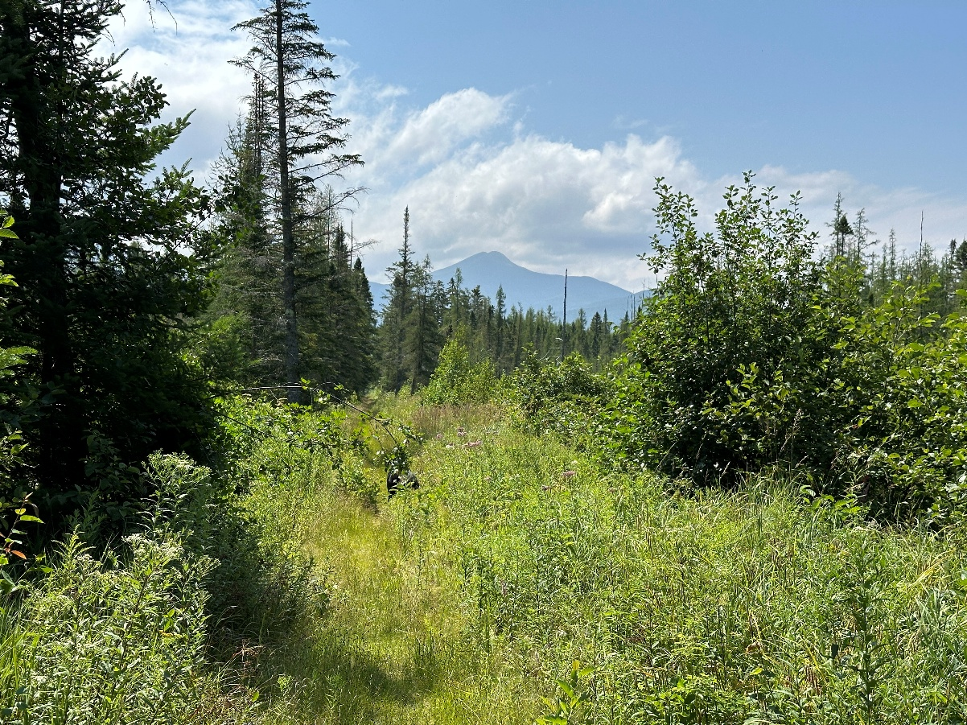
View across a wetland towards the White Mountains.

