
Capital Improvements Plan
FY2026 through FY2032

Town of Bethlehem, NH

CIP Committee

TABLE OF CONTENTS
Introduction 3
CIP Processes 4
Conclusion and Recommendations 5

Introduction
The preparation and adoption of a Capital Improvements Plan (CIP) is an important part of Bethlehem’s planning process. A CIP aims to recognize and resolve deficiencies in existing public facilities and anticipate and meet future demand for capital facilities. A CIP is a multi-year schedule that lays out a series of municipal projects and their associated costs. Over the six-year period considered by the CIP, it shows how the Town should plan to expand or renovate facilities and services to meet the demands of existing or new population and businesses.
A CIP is an advisory document that can serve a number of purposes, among them to:
• Guide the Select Board in the annual budgeting processes.
• Contribute to stabilizing the Town’s real property tax rate.
• Aid the prioritization, coordination, and sequencing of various municipal improvements.
• Inform residents, business owners, and developers of planned improvements.
It must be emphasized that the CIP is purely advisory in nature. Ultimate funding decisions are subject to the budgeting process and the annual Town Meeting. The CIP Committee is bringing Department project requests to the attention of the Town, along with recommended priorities, in the hope of facilitating decisions.
The CIP Committee will review and update the CIP each year prior to budget deliberations. The CIP may be modified each year based on changes in needs and priorities. There can be projects proposed where the CIP Committee has determined that there is not enough information to make a recommendation concerning a proposed capital project. These are topics in the opinion of the Committee that should be studied in further detail before funding decisions should be made.
The Capital Improvements Committee has worked hard over the past year to improve the effectiveness of capital facilities programming in Bethlehem. It is hoped that the improvements made during this time can continue to be refined and evaluated for their effectiveness in future years. The CIP Committee believes that Bethlehem has made great strides in process and format of the Capital Improvements Plan and is hopeful that the improvements have made a difference to the Select Board as they prepare budgets each year.

CIP Processes

Conclusion and Recommendations
Major Capital Projects
The Committee has identified the following significant projects that should be addressed in the next few years whose costs are significant enough that bonding may be needed. Below are outlines of the projects as viewed by the Committee.
- Transfer Station. With an expected closure date for the NCES Landfill in 2027, the Town must provide a transfer station for its residents. Construction would commence no later than 2026. Currently there is an estimated $325,282 in the Solid Waste Capital Reserve Fund. Although many attempts were made to fund this project through federal grants, none were successful to date. One EPA grant application is still waiting for possible approval but if that funding source does not come through, the Town is faced with two options:
  - Fund a bare-bones transfer station using the approximate $350,000 that is expected in the Capital Reserve by end of 2026 and complete additional phases as funding becomes available.
  - The CIP Committee is recommending to seek a bond or borrow the cost to complete the project before 1/1/27. To fund the full project at the outset helps protect against rising construction costs. By spreading that cost over a longer period of time, future Bethlehem residents can also contribute to the cost of the project.
Approximate cost of a functional transfer station that is able to not just collect solid waste but apply sustainable and ecological practices of recycling, repurposing and reusing is estimated to be $900,000.
- Public Safety Building. The space currently used for our Fire/EMS/Police departments is in the basement of Town Hall and is not adequate in both size and functionality. Once the Transfer Station is completed, this will be the next large ticket item for the Town. Cost is difficult to estimate at this time as a location site has not been selected or purchased. There is a Capital Reserve Fund with $98,854. The CIP Committee recognizes that it would be least costly to the Town to fund most of this project with a grant or grants, with potential matching funds coming from the Capital Reserve Account(s). However, if grants are not found, the CIP Committee recommends seeking a bond to complete the project.

- Sidewalk from BES to Town Hall parking lot. This project has been accepted by NH DOT to be included in their 10-year plan. The estimated year for completion is 2034. Because the DOT funding covers 80% of the project, the Town will need an estimated $200,000 for matching funds. A Grant Match Capital Reserve warrant was passed in 2025 and has a nominal amount of $20,000. The CIP Committee recommends an additional $30,000 be added to this Capital Reserve fund.
- Town Hall Front Steps – Without an engineering study and cost estimate, it’s difficult to include this in building maintenance capital improvements. The CIP Committee recommends the completion of the engineering study in 2026. Another option may be to merge this project into a future funding opportunity.
Past Financial Trends
Prior to 2025, departments heads were determining any capital reserve fund requests, with review and approval from the Select Board. With the formation of the CIP Committee in 2024, we now have a dynamic working document that projects capital expenses over the next six years. This document becomes the template for revisions each year to plan for our capital improvement needs going forward.
Over the past six years, the municipal budget has increased an average of 6.42%. When the Capital Reserves are added to the annual budget, the average increase over the past six years was 7.28%. It’s notable that a large increase in 2024 Capital Reserve was due to the Visitor Center Roof and Fire Truck payoff; both expenses that were not planned for.
*includes petition warrant articles that passed
**municipal only
Capital Reserve Funds by Department
This section covers the following Capital Reserve Funds: Town Building maintenance, Tech/Computer, Property Assessment, and Solid Waste Disposal.
General Government/Town Building Maintenance
In 2025, the Town completed the Visitor Center roof and foundation repair. This was paid for by Warrant Article. Also in 2025, new municipal software for accounts payable, general ledger, budgeting and payroll was implemented. This was paid for from the operating budget and the Tech/Computer Capital Reserve Fund.
The CIP Committee recommends adding $30,000 to the Town Building Maintenance Capital Reserve Fund, which currently has a balance of $69,975. There are several projects that have already been identified including : the front steps repair/replacement, masonry work, window replacements, and potential future roof repairs. Some of these expenses will be large. The CIP Committee will be researching best funding opportunities.
In 2025, we increased the operating budget for assessing services and moved some of the anticipated cyclical reevaluation expense into the operating budget. Therefore, the CIP Committee is recommending a reduced capital reserve request in 2026 from $26,000 to $5,000.
The Town will have a separate warrant to fund the construction of the new Transfer Station. As a result, the CIP Committee will not be asking for any additional funding of the Capital Reserve Account. The Solid Waste Capital Reserve fund has been accumulating since 2018 and has a current balance of $316,399. Those monies can be allocated for necessary pre-construction and construction expenses.
Public Safety
This section covers fire, ambulance and police assets.
A new fire truck arrived in summer of 2025, replacing the 2004 engine. This was fully funded through taxpayer money, ARPA funds, and the Fire Truck Capital Reserve Fund. We also purchased a used utility truck from the Village for $28,500. As a result, the Fire Truck Capital Reserve fund has been depleted from the estimated $510,000 that it held and is now estimated to be $36,914. The 2000 FL80 Pumper truck is scheduled to be replaced by 2027. The 1998 tanker will need to be replaced in 2034 and therefore the CIP Committee is recommending $50,000 be added to the Fire Truck capital reserve.
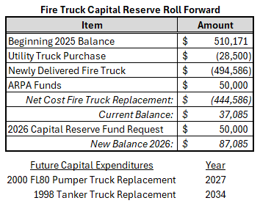

The Fire Dept Emergency Equipment Capital Reserve fund is estimated to be $17,000. In 2025, we updated the airpacks and added the ambulance lift, using $53,400 from this fund. The CIP Committee is recommending adding $35,000 to this fund.
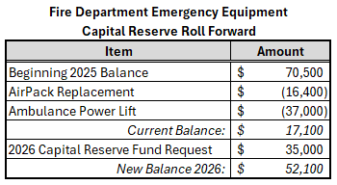
The 2016 ambulance will need to be replaced in 2028. There is an estimated $125,000 in the Ambulance Capital Reserve Fund. Estimated cost is $400,000. There will be a warrant to create a revolving fund for ambulance revenue to offset the purchase cost. As a result of the anticipated creation of the revolving fund, the CIP Committee is recommending asking for $25,000 to be added to the ambulance capital reserve.
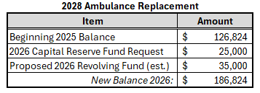
The police cruisers have been on a designated replacement cycle. In 2025, we replaced Cruiser 3. Next to be replaced is Cruiser 4 in 2027. There is an estimated $60,800 in the Police Cruiser Capital Reserve Fund and the CIP Committee is recommending $35,000 to be added to the Police Cruiser Capital Reserve.
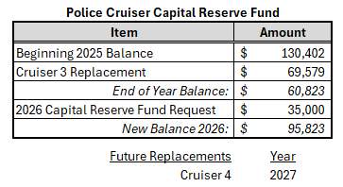
Highways, Streets and Bridges
In 2024, the Highway Department entered into a 7-year lease agreement for the front loader truck due to financial incentives and higher trade in value.
In 2024, the Road Agent ordered the replacement truck for the 2009 5-ton dump truck, estimated cost of $241,000. This should be delivered in 2026, which is when the invoice is due. The money for this purchase fund had been allocated from the Highway Equipment Capital Reserve Fund and the Highway Revolving Fund but a NHDES Clean Fleet grant was awarded in October 2025, paying for 80% of this purchase – saving the Town $192,800.
The next anticipated replacement is the 2011 5-ton dump truck in 2027 at the earliest. Estimated balance in Highway Equipment Capital Reserve Fund is $175,000. The CIP Committee is recommending $50,000 to be added to this fund.
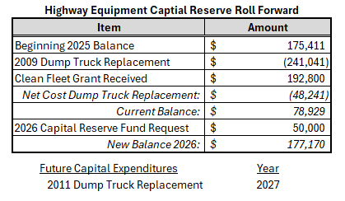
A North Country Council contract for a Road Study has been approved. Additional information from this study will be included in the 2026 CIP Committee Report.
$250,000 is put in the budget for asphalt for road work. As construction costs continue to rise and make it difficult to plan for, the CIP Committee is recommending funding the Road Maintenance Capital Reserve Fund at $70,000. It currently has a balance of estimated $22,667.
Recreation
Projects completed in 2025 included: the basketball resurfacing project, the baseball field’s Cal Ripken expansion, the pool entrance building roof was replaced, and a portion of the cement pool deck was repaired. In 2024, the tennis courts were resurfaced. All recreation department properties expenses were paid for out of the operating budget and the Recreation revolving fund. The CIP Committee is recommending adding $25,000 to the Recreation/Pool Capital Reserve fund to continue funding the recreation properties maintenance, which would bring the balance of $59,412.
An anticipated project for 2026 is a replacement of the Snack Shack.

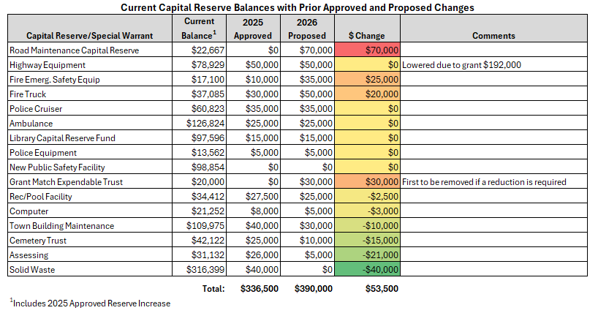
Respectfully Submitted,
Richard Southwell (Citizen Representative)
Vicki Francis (Citizen Representative)
Nancy Strand (Select Board Representative)
Jerry Blancard (Planning Board Representative)
Mary Moritz (Town Administrator)

