Bethlehem Board of Selectmen
Meeting Minutes
March 16th, 2026
In person – Chairwoman Strand, Selectman MacDonald, Selectwoman Knowles, Selectwoman Hibberd, and Selectman Bruno.
Chairwoman Strand opened the meeting at 6:00 and read the following statement:
In our last meeting, there were concerns raised about the Select Board being “mowed over” by Mary Moritz, our Town Administrator. Mike responded well and I agree with his response, however at that time I did not want to continue the discussion any further than we had to.
However, my statement here is a response to that allegation.
As a Select Board, we rely on Mary’s knowledge often. She’s an invaluable source of information on town and state regulations, especially those governing Select Board business. As chair this past year, I’ve often asked her to explain an issue in a SB meeting, or add to what’s already been said, or to answer a question. This is for the benefit of everyone, getting the correct information out to the public.
The very nature of Mary’s job means that she knows a lot more about many aspects of town business than we do as SB members. We don’t often get into the everyday details of the dozens of tasks and projects that she juggles. However, one of her jobs is an administrator to the Select Board. She is always available to any of us if we have questions or concerns. When we have non-public discussions, or even in my one-on-one discussions with her, she presents the facts, often covering multiple views on an issue, and frequently says “It’s up to you – the SB – to make a decision.”
Mary is her own biggest critic and always cares about the customer service aspect of her work. I have witnessed many times when being in her office that we’re interrupted by a resident with a concern that she needed to address. She’s always happy to do so and makes this a high priority part of her job. We are lucky to have her.
I have never felt she overstepped and I wish I had responded in this way to the concern that was raised.
Finally, I don’t believe social media is the place to air grievances if you want to actually resolve something. I do invite anyone with concerns to come to public input at the SB meetings, or if you don’t like public exposure, reach out through email, or leave a message for any of us in the Town Office. Whatever your concern, we will do our best to respond – publicly or privately - and if needed, offer to meet for more information. Your input is welcome and important.
Public Input- Jason Mooney updated the board that he had met with Selectwoman Knowles and Rec Director Abbie Sawyer to adapt the snack shack plan and rehab the building rather than rebuild. Sean Gawlick and Jason Mooney continued they estimate the rehab project around $1,000 and that would include a new roof and removing the wasp issue. The board thanked Jason and Sean for their flexibility and efforts to rectify the snack shack.
Nominate a Board Chair- Chairwoman Strand nominated Selectman Bruno Chair. Selectman MacDonald seconded and all were in favor.
Selectwoman Hibberd nominated Selectwoman Knowles Vice Chair. Selectman MacDonald seconded and all were in favor.
Liaison- The board discussed liaisons and the completed Liaison list is Appendix A.
Select Board Procedures-The board discussed Select Board procedures, and it is Appendix B.
To-Do list- The board discussed the To-Do list and removed the 30% solar tax rebate because it is completed and added reviewing Master Plan goals, Granite State Ambassadors under Economic Development, and 79-E. The revised To-Do list is Appendix C.
Updates and Other Business- Bruce Caplain, Bike the North Country, requested permission to add a gear shed at the Elm Street Ball fields.
Chairman Bruno motioned to approve adding a gear shed at the Elm Street Ball fields contingent on seeking input from Brett Jackson, Road Agent, and Abbie Sawyer, Rec Director. Selectman MacDonald seconded and all were in favor.
The board has decided on the following dates for future meetings: 3/23, 4/6, and 4/20.
Chairman Bruno motioned to adjourn at 7:30. Selectman MacDonald seconded, and all were in favor.
Respectfully submitted,
Mary Moritz

Appendix A:
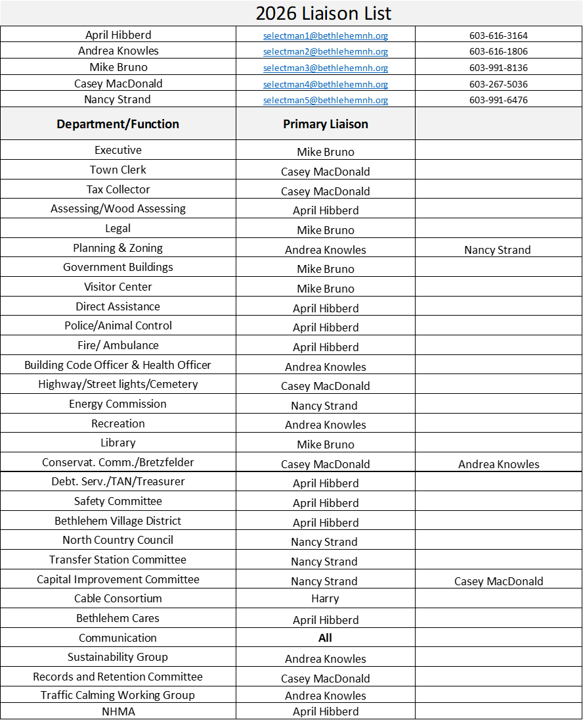

Appendix B:
Board of Selectmen Guidelines & Procedures
Adopted 3/31/2025
TOWN OF BETHLEHEM
BOARD OF SELECTMEN GUIDELINES & PROCEDURES

The Bethlehem Board of Selectmen hereby adopts these operational guidelines and procedures pertaining to the functions of the Board and the conduct of its members.
I. General Information
The Board of Selectmen consists of five equal members who shall operate by majority vote to serve as the governing body of the Town, manage the prudential affairs of the Town, and to perform the duties prescribed by law in accordance with the Right-to-Know Law (RSA 91-A).
Individual Selectmen have no authority to make decisions on behalf of the Town or to take any action as a Town Official except upon majority vote of the Board or as otherwise allowed by law. This does not prohibit Selectmen from acting as an ordinary citizen of the Town by expressing personal viewpoints and opinions on municipal matters to the extent that such information is based on encounters and observations derived outside of the privileged purview of a Selectman.
The Board of Selectmen derives its authority from NH State Law as specifically set forth in the Revised Statutes Annotated and as further established under common law (court decisions). A general rule of thumb is the Board of Selectmen does not have the final authority to act on any particular issue unless there is a specific law granting such authority or when Town Meeting has lawfully delegated such authority to the Selectmen.
II. Organization
The Board shall by majority elect from its membership a Chair who shall preside over all Board meetings and have duties outlined below.
The Board shall by majority elect from its membership a Vice Chair who shall have all the duties and responsibilities of the Chair in the event of a vacancy or disqualification or absence.
The Board shall by majority elect from its membership (or appoint designees, as appropriate) liaison’s and ex-officio members.
These appointees shall have a responsibility to keep the rest of the Board of Selectmen informed on important events and news related to the other boards they serve on and department’s they are a liaison to.
Unless specifically discussed at a Board of Selectmen meeting, votes of liaisons and ex-officio members represent the opinions of the individual, not an opinion of the Board of Selectmen as a whole.
The Chair and all liaisons serve in these positions at the pleasure of the Board and a majority of the Board may vote to reorganize at any time for any reason.
III. Duties of Selectmen
A. Chair
The Chair shall preside over all Board meeting and shall have the authority to:
1. Review and approve meeting agendas as drafted by the Administrative Assistant.
2. Ensure that informal parliamentary procedures are followed, with the assistance of the Administrative Assistant.
3. Maintain orderly Board meetings.
4. Call for special or emergency meetings.
5. Represent the Town at ceremonial events.
6. Serve as the Board spokesperson by presenting the official viewpoint of the Board of Selectmen to the media, citizens, government agencies, civic groups, and others.
8. Along with the Administrative Assistant, serve as the point of contact with Town Counsel.
9. The Chair may delegate any of these duties to other Selectmen as may be deemed necessary.
These guidelines are not intended to prevent other Selectmen from attending ceremonial events or expressing their personal opinions so long as they make clear they are speaking on behalf of themselves and not the Board.
Nothing herein is intended to prohibit the remaining members of the Board of Selectmen from voting to override a ruling of the Chair, nor is anything intended to prevent the Chair from delegating his/her authority as may be deemed necessary.
B. Partial List of Board of Selectmen’s Duties & Responsibilities
This is meant to be a general overview of the Board of Selectmen’s duties. Major duties from statute:
1. Act as Agents to Expend Capital Reserve Funds (RSA 35:15).
2. Adopt Personnel Policies (RSA 105:2-a).
3. Adopt Welfare (Public Assistance) Guidelines (RSA 165:1).
4. Adopt Police Policies (RSA 105:2-a)
5. Appoint an Emergency Management Director (RSA 21-P:39).
6. Appoint Election Inspectors (RSA 658).
7. Make Appointments to Town boards and committees and fill all vacancies that should occur unless otherwise outlined by statute or vote of the Town (RAS 669:1-75).
8. Appraise Taxable Property, Issue Abatements, & Approve Exemptions (RSA 72, 74-76).
9. Approve Appointments of Deputy Town Clerk, Deputy Tax Collector, and Deputy Treasurer (RSA 41:29-a, 45-c).
10. Approve Budget Line Item Transfers (RSA 31:20).
11. Approve the Acquisition of Real Property Interests in the Name of the Town by the Conservation Commission (RSA 36-A:4).
12. Approve Town Expenditures (RSA 41-9).
13. Assessment of Current Use Change Taxes (RSA 79-A).
14. Assessment of Timber Taxes (RSA 79).
15. Assessment & Payment of Educational Taxes (RSA 194:7 & 198).
16. Encumber Unexpended Funds (RSA 32:7).
17. Establish & Maintain Internal Control Procedures (RSA 41:9).
18. Establish Boards and Committees (RSA 41:8).
19. Layout Town Highways, name streets (RSA 231).
20. Negotiate Inter-Municipal Agreements (RSA 53-A:1 & 162-G).
21. Nominate the Appointment of a Health Officer (RSA 128:1) & Approve the Appointment of a Deputy Health Officer (RSA 128:5-b).
22. Order the Cutting or Removal of Trees within a Designated Scenic Highway which present a public nuisance pursuant to RSA 231:145 and 231:146, when such trees or portions of such trees pose an imminent threat to safety or property (RSA 231-158)
23. Perambulation of Town Boundaries (RSA 51:2).
24. Prepare Budget Recommendations (RSA 32).
25. Prepare the Annual Town Report (RSA 41:13-14).
26. Prepare Town Meeting Warrants (RSA 39:2).
27. Propose Amendments to the Zoning Ordinance (RSA 675:3).
28. Regulate Junkyards (RSA 236:115).
29. Regulate Town Highways & Commons (RSA 41:11).
30. Regulate the Town Transfer Station, Trash Collection & Transportation, and Voluntary Recycling (RSA 149-M;17).
31. Sit on the Board of Health & Adopt Health Regulations (RSA 147).
32. Submit Reports to the NH Department of Revenue Administration (RSA 21-J:34).
Major duties delegated by Town Meeting:
1. To serve as Cemetery Trustees (RSA289:6, II-a;)
2. To accept on behalf of the town, gifts, legacies and devises made to the Town in trust for any public purpose as permitted by RSA 31:19, until rescinded. (ATM 1994 Art. 22)
3. To apply for, accept and expend, without further action by the town meeting, unanticipated money from a state, federal or other governmental unit or private source which becomes available during the fiscal year. Until rescinded (RSA31-95-b, ATM 1994 Art. 19)
4. To issue tax anticipation notes, until rescinded (RSA 33:7, ATM 1994 Art. 21).
5. To accept gifts of personal property, other than money, which may be offered to the Town for any public purpose in accordance with RSA 31:95-e, until rescinded (ATM 1994 Art. 23)
6. To convey any real estate acquired by the tax collector’s deed pursuant to RSA 80:80. Such conveyance shall be by deed following a public auction, or the property may be sold by advertised sealed bids or may be otherwise disposed of as justice may require (RSA 80:80 and ATM 1995 Article 15).

IV. Board of Selectmen Meetings
The Board of Selectmen can only act in a duly posted public session unless a subject matter is specifically exempt by law from such requirement. Notice of all meetings shall be posted at least 24 hours in advance of the meeting (except in the event of an emergency as noted herein) on the Town’s website, Post Office and the Town Hall public bulletin board. Additional postings may be made at other locations to the extent practical. There is no legal requirement to post an agenda with a notice of meeting.
The Board of Selectmen may meet in non-public session only to discuss the subject matters referenced in RSA 91-A:3, II, provided that such action is preceded by a motion, second and roll call vote that indicates the precise reasons for entering a non-public session, including a reference to the applicable statutory citation; and furthermore provided that such action can only take place during a duly posted public meeting. Upon the close of non-public session business, the Board of Selectmen may, by 3/5 vote, seal the minutes until such time as divulgence is otherwise permitted under law; otherwise a draft of the non-public session minutes shall be made available for public inspection in the Office of the Town Administrator within 72 hours.

The Board will from time to time agree by consensus to a meeting schedule, subject to adjustments for appointments or other events.
The public has a right to attend Board of Selectmen meetings, except under certain exemptions for non-public sessions as outlined in statute. Members of the public at meetings wishing to speak can only do so if recognized by the Chair and the Chair may place limits on the timing of public comment, along with the length of time and the content of input. Public input should be directed to the Board as a whole, not to individual Board members. Members of the public who would like to address the Board regarding an issue not on the agenda should make an appointment with the Town Administrator to be on the agenda of a future meeting. Such appointments are subject to the approval of the Chair and must be made by 12:00 p.m. the Thursday before any given meeting.
Board members shall follow commonly accepted rules of courtesy, including using a civil tone and language, only one person speaking at a time, and waiting to be acknowledged by the Chair before speaking. Each subject discussed will be clearly announced.
Votes should be taken by the Board upon a clearly stated motion and a second whenever the Board members wish to go on record as having made a decision on behalf of the Town. If there is a motion on the floor that has been seconded, the Board will focus discussion to that subject until it has been voted on. In some instances, the Board may wish to convey its opinion or consent by a simple consensus process.
It is illegal for the Board of Selectmen to make any decisions by use of a secret ballot or by email or in such a way as to be contrary to the Right-to-Know Law.
Selectmen should disqualify themselves from the Board and step down from all participation in deliberations (including voting) on any subject matter where there is a conflict of interest or perceived conflict of interest. A Selectman should voluntarily disqualify himself/herself whenever he/she has a direct personal or pecuniary interest in the outcome.
Minutes of all meetings of Board of Selectmen shall be kept, maintained and made available to the public as per RSA91-A:2 & 4. The minimum content of the minutes shall be as set forth in RSA 91-A:2 & 4, but nothing herein is intended to prohibit the Selectmen from including such additional information as they may deem necessary. Sealed minutes shall be held in the custody of the Office of the Administrative Assistant. Draft minutes shall be noted as such.
V. Relationships with Staff
The Board of Selectmen has a statutory duty to manage the prudential affairs of the town (RSA 41:8). Toward this end there is a collective responsibility to monitor the activities of town departments and staff to ensure that operations are conducted in a manner consistent with applicable laws and policies. Individual Selectmen should become familiar with town operations but should refrain from directing the daily operations, task assignments or actions of a town department without prior authorization from a majority of the Board of Selectmen. If a Selectman finds that town departments or staff are operating in a manner inconsistent with applicable laws or policies or determines that there is a need to revise town policies, he/she should bring the matter to the attention of the department head or the full Board of Selectmen for review and discussion.
It is understood that the Town Administrator responsibilities include providing administrative support for Selectmen; nothing in this section is intended to restrict a Selectman’s ability to work with the Town Administrator in such fashion.
VI. Relationships with Counsel
Selectmen may consult with the attorneys employed by the New Hampshire Municipal Association at will on matters arising during the conduct of town business. Selectmen shall refrain from contacting other Town Attorneys without prior approval of the full Board of Selectmen, except that the Chair may consult with any Town Attorney as necessary in the fulfillment of his/her duty to plan and organize town business for Selectmen’s meetings, when the Town is threatened with litigation, and in emergency situations.
VII. Violations
1. There are no defined consequences under NH law for failure to comply with these guidelines. However, it should be noted that the remaining members of the Board of Selectmen may vote to publicly censure a Selectman for repeated or egregious failures to meet these obligations.
2. In the event that a quorum of the Board is of the opinion that one of the Selectmen has violated State Law, then they may vote in public session to initiate judicial removal proceedings and/or petition a court of competent jurisdiction for the imposition of such other penalties as may be allowed by law.
Approved on March 16, 2026

______________________________________ ____________________________________
Nancy Strand Andrea Knowles

______________________________________ ___________________________________
April Hibberd Mike Bruno

______________________________________
Casey MacDonald
Appendix C:

