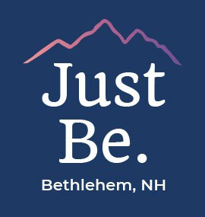
Zoning Board Agenda
Tuesday June 9, 2026 6:00PM

2155 Main Street Bethlehem NH 3rd Floor Meeting Room

Call to Order
- Roll Call
- Agenda Review – The order in which the agenda is presented may be subject to change

Previous Meeting Minutes

April 14, 2026
- Continued Business –
- Application 2026-EWDR-419-052: North Country Environmental Services Inc (Owner) Rudarpa North Country LLC (Agent/Lessee) are requesting an Equitable Waiver of Dimensional Requirements because of two (2) encroachments within the northern boundary setbacks. The structures include the candlestick ﬂare and part of a propane tank.

Board and Administrative Communications
- Public Participation – Public Participation shall pertain to topics within the purview of the Planning Board
- Adjournment

Join Zoom Meeting
https://us06web.zoom.us/j/86471783402?pwd=HaZwtofMdPjTqF3gAZQsNL0ymfRbms.1

Meeting ID: 864 7178 3402
Passcode: 389048

